

The Wealth of Nations



*January 2, 2024*

*Kassie K*

1 -Data Policies 1

Data Governance Policy: 1

Data Classification and Handling: 1

Data Quality Management: 1

Data Security and Access Controls: 1

Data Retention and Disposal: 2

Data Privacy and Compliance: 2

Data Breach Response Plan: 2

Data Lifecycle Management: 2

Training and Awareness: 2

Monitoring and Auditing: 2

2 - Step by step demonstration of Excel dashboard 3

3 - Step by step demonstration of Tableau dashboard 9

# -Data Policies

Data policies and procedures are crucial components of an organization's overall governance framework. They provide guidelines and rules for managing data throughout its lifecycle, ensuring that it is handled, stored, and processed in a secure, compliant, and efficient manner. Here are some key elements typically included in data policies and procedures:

## **Data Governance Policy**:

Objective: Define the overall purpose and goals of data governance within the organization.

Responsibilities: Clearly outline roles and responsibilities for data management, including data stewards, data owners, and data custodians.

## **Data Classification and Handling:**

Classification Criteria: Specify criteria for classifying data into different categories (e.g., sensitive, confidential, public).

Handling Guidelines: Provide instructions on how each category of data should be handled, stored, and transmitted.

## **Data Quality Management:**

Quality Standards: Define standards for data accuracy, completeness, consistency, and timeliness.

Data Profiling: Outline procedures for assessing and monitoring data quality on an ongoing basis.

## **Data Security and Access Controls:**

Access Policies: Establish policies for granting and revoking access to different data sets based on roles and responsibilities.

Encryption: Specify when and how data should be encrypted to protect sensitive information.

## **Data Retention and Disposal:**

Retention Periods: Define the duration for which different types of data should be retained.

Disposal Procedures: Outline secure methods for data disposal when it reaches the end of its lifecycle.

## **Data Privacy and Compliance:**

Privacy Policies: Address how the organization collects, uses, and shares personal information in compliance with relevant privacy laws (e.g., GDPR, CCPA).

Compliance Checks: Specify procedures for regularly auditing and ensuring compliance with data protection regulations.

## **Data Breach Response Plan:**

Incident Reporting: Establish a clear process for reporting and responding to data breaches.

Communication Plan: Define how the organization will communicate with stakeholders in the event of a data breach.

## **Data Lifecycle Management:**

Creation and Collection: Outline procedures for capturing and entering data into the system.

Storage and Retrieval: Define how data is stored, archived, and retrieved.

Archiving and Purging: Specify processes for archiving historical data and purging obsolete data.

## **Training and Awareness:**

Training Programs: Implement training programs to educate employees about data policies and procedures.

Awareness Campaigns: Conduct awareness campaigns to keep employees informed about the importance of data management.

## **Monitoring and Auditing:**

Audit Trails: Implement mechanisms for tracking and auditing data access and modifications.

Monitoring Tools: Use tools to monitor compliance with data policies and identify any anomalies or unauthorized activities.

These elements collectively contribute to the establishment of a robust data management framework, helping organizations protect sensitive information, maintain data integrity, and comply with regulatory requirements. Regular reviews and updates to data policies and procedures are essential to adapt to evolving business needs and changing regulatory landscapes.

### 

### - Step by step demonstration of Excel

Step 1

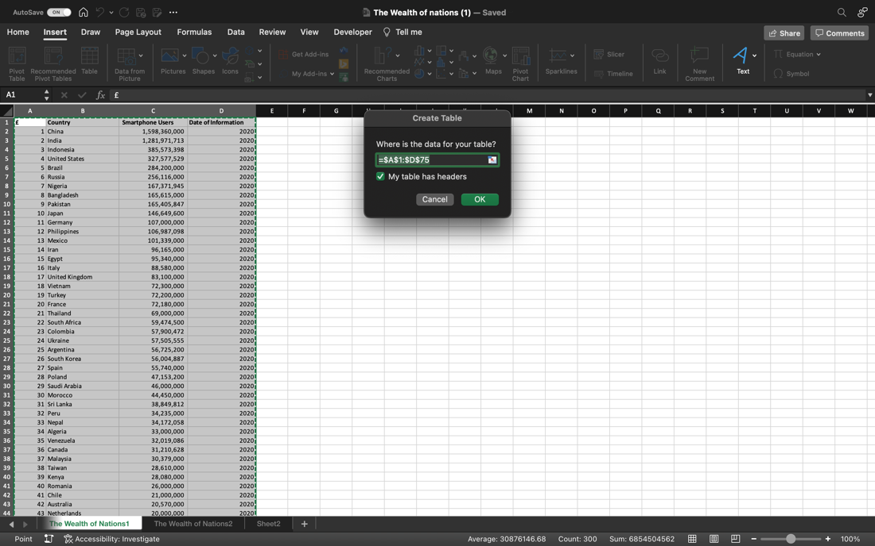

Step 2

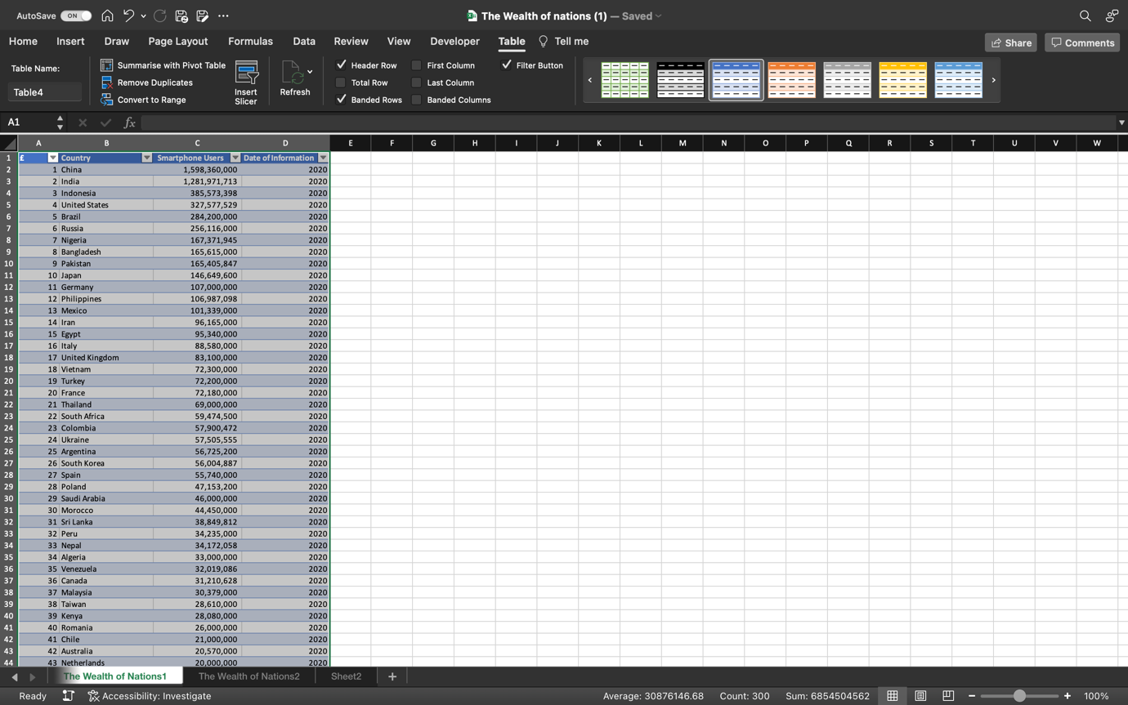

Step 3

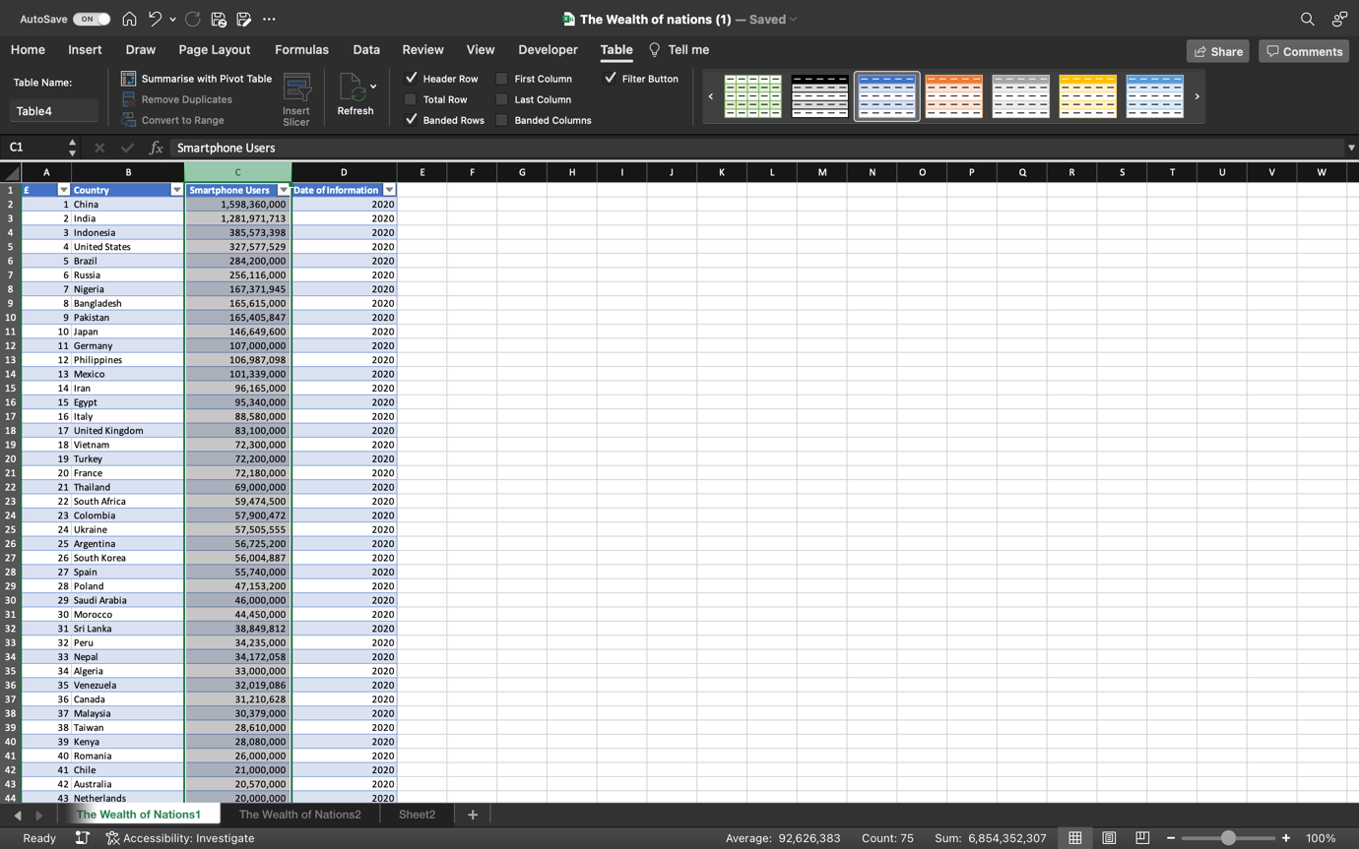

Step 4

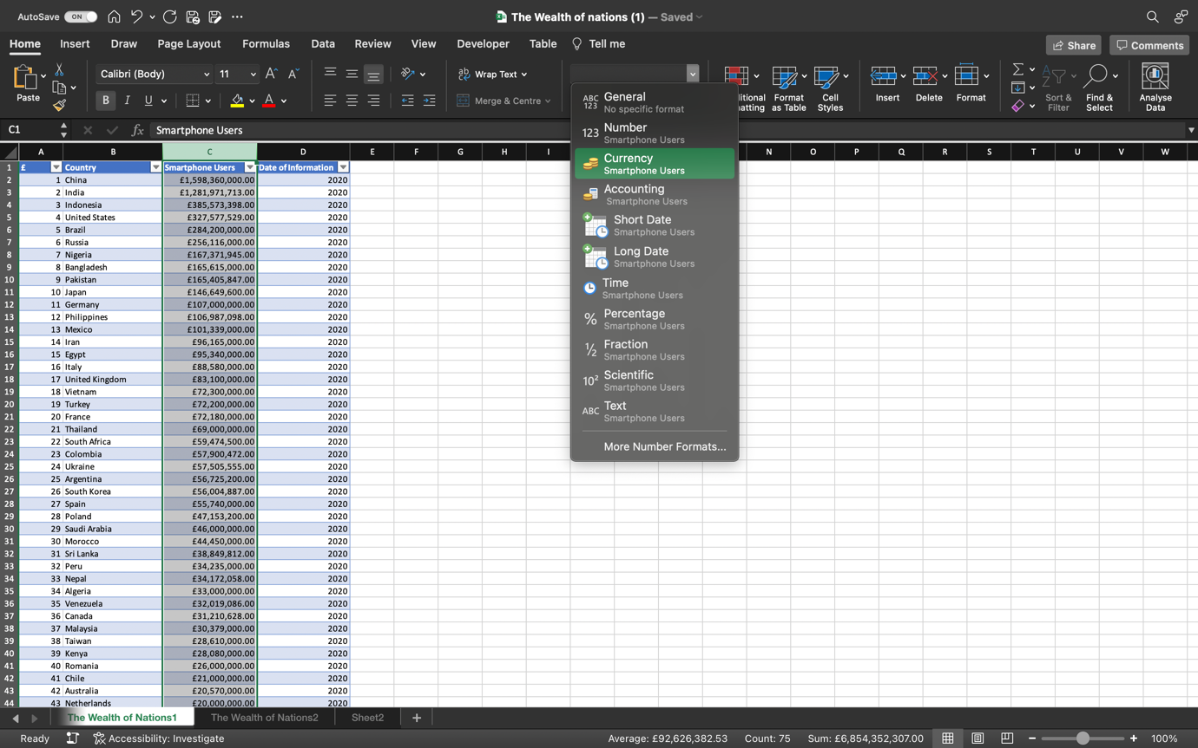

Step 5

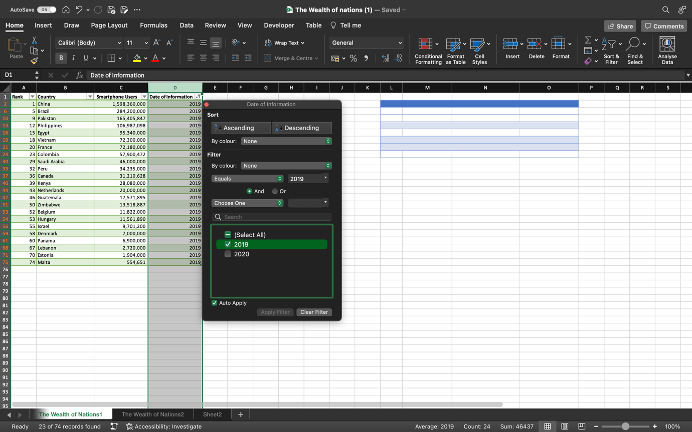

Step 6

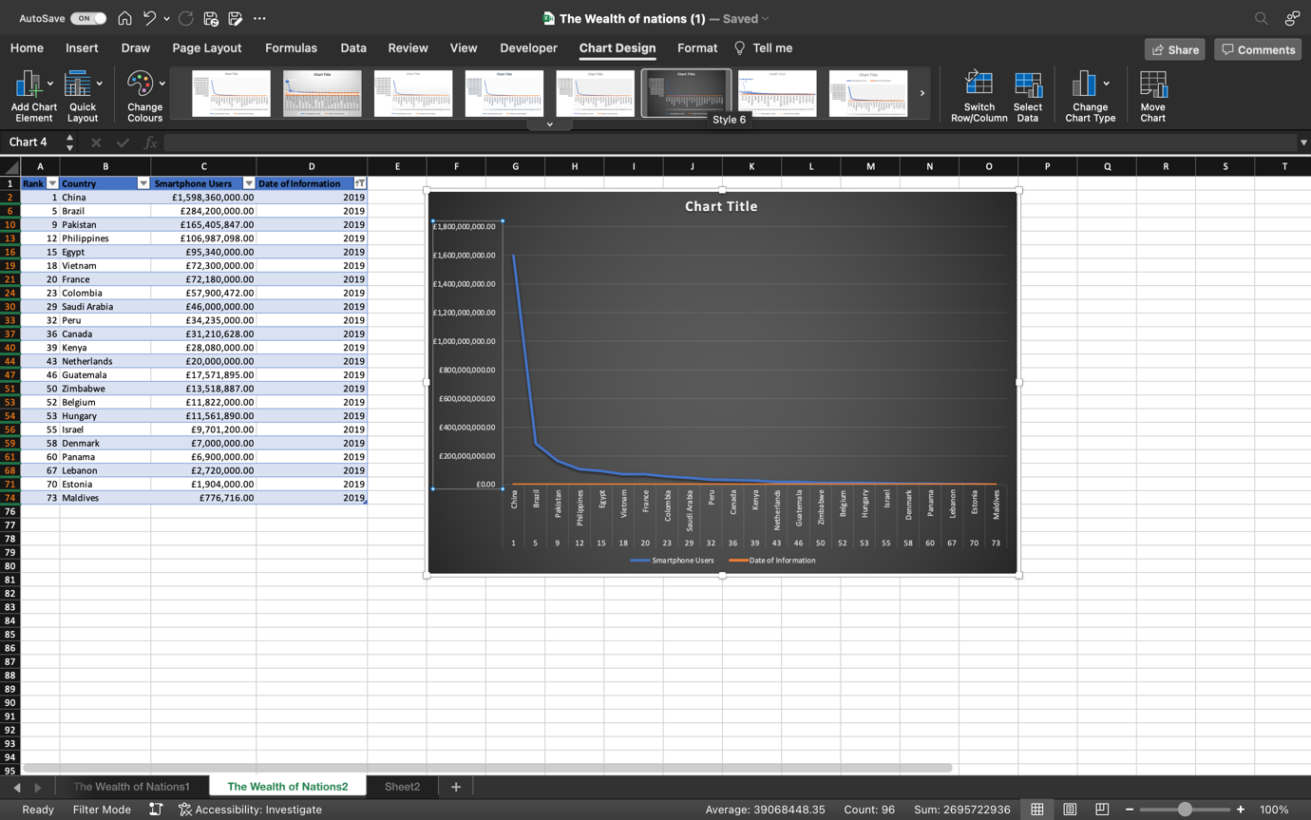

Step 7

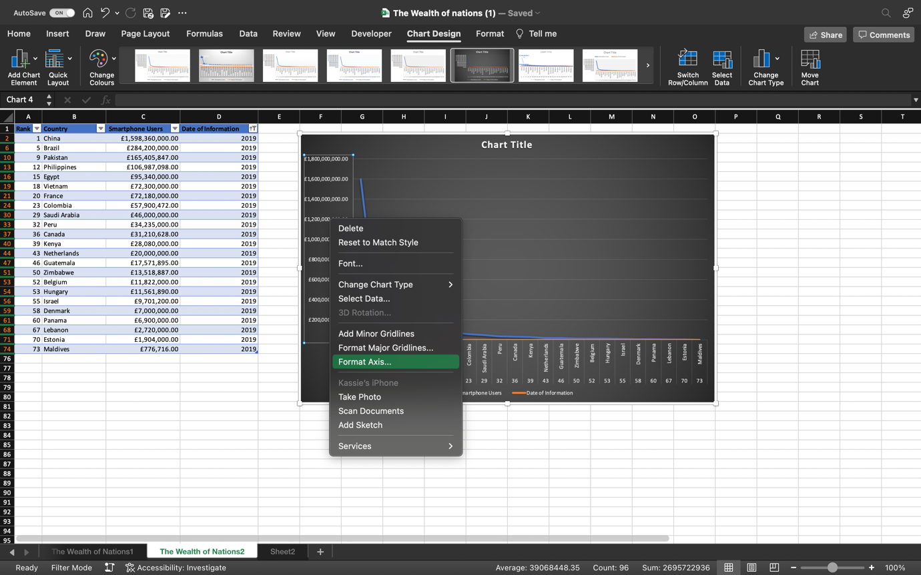

Step 8 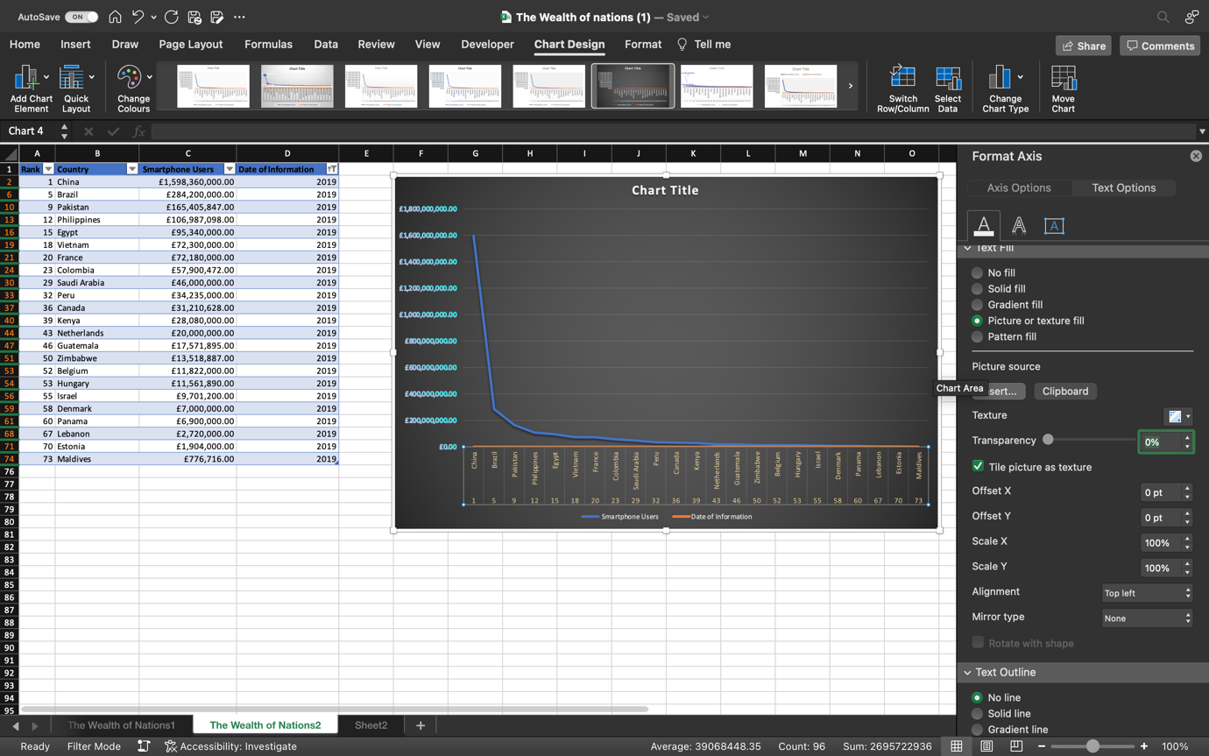

#### Step 9

Step 10

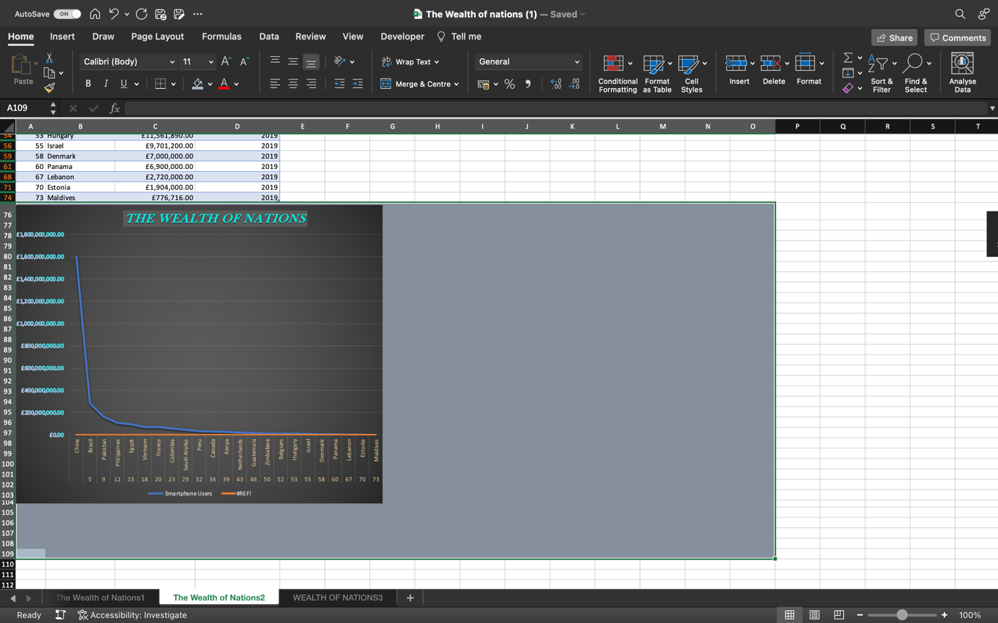

Step 11

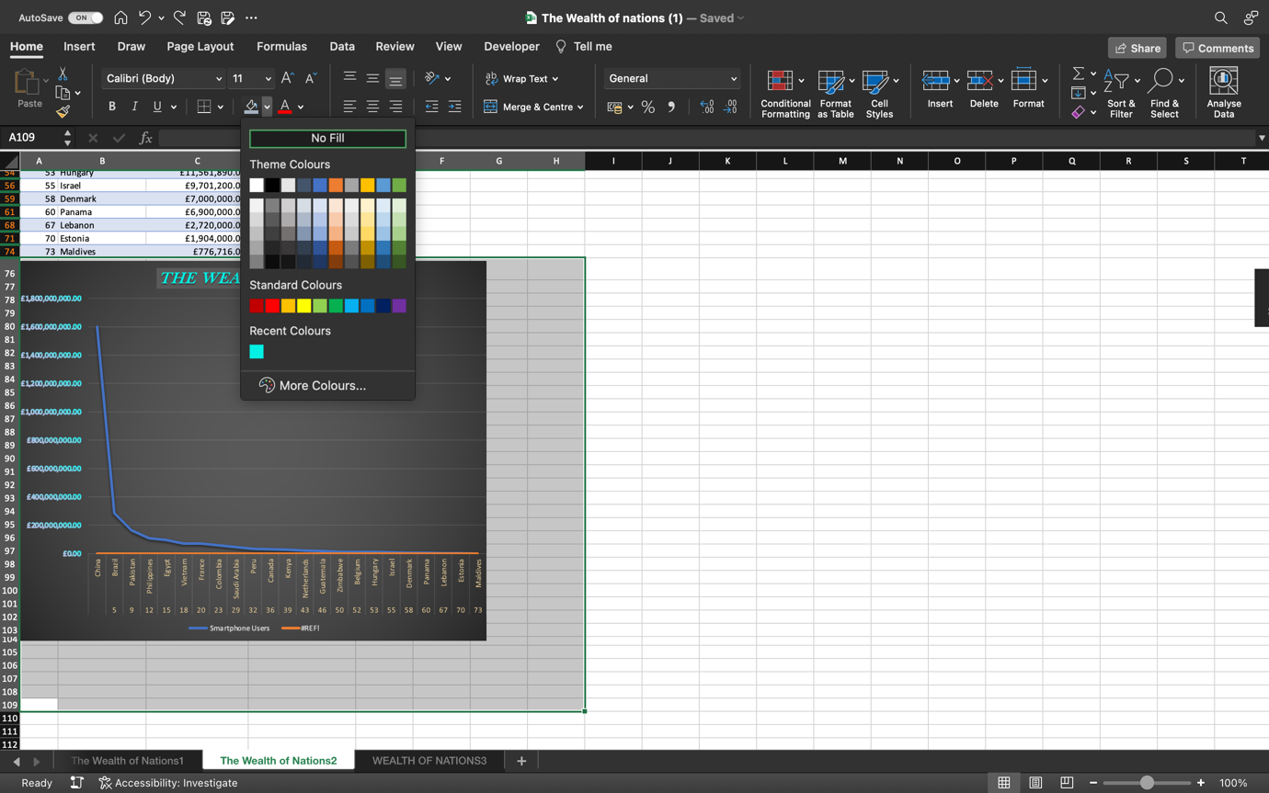

Step 12

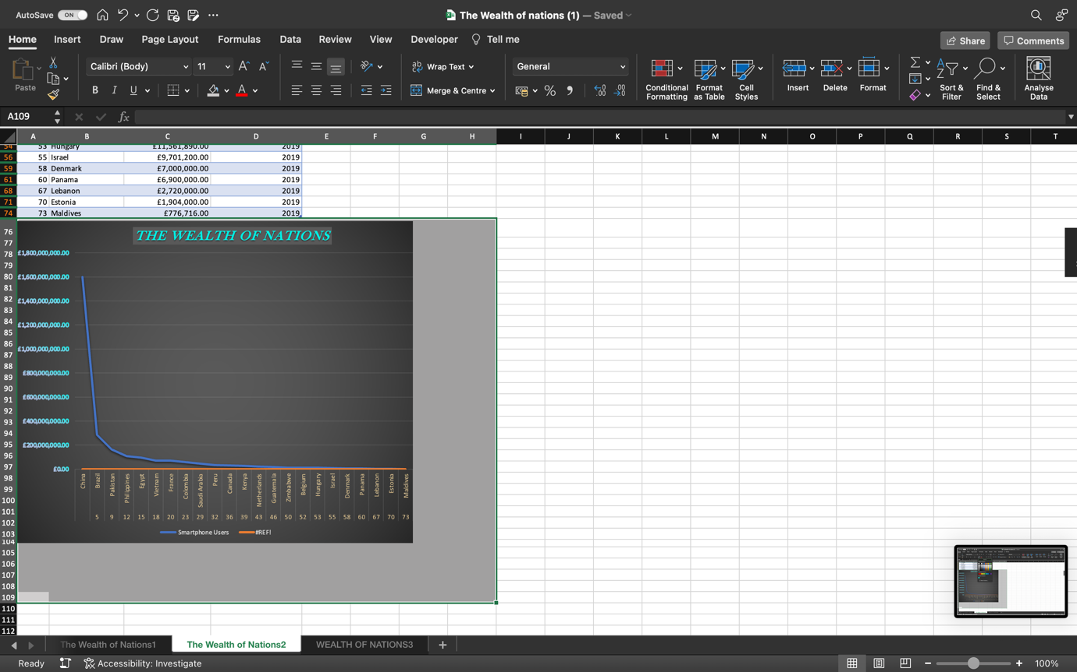

### 3 - Step by step demonstration of Tableau

Step 1 Locating a file to open it on Tableau.

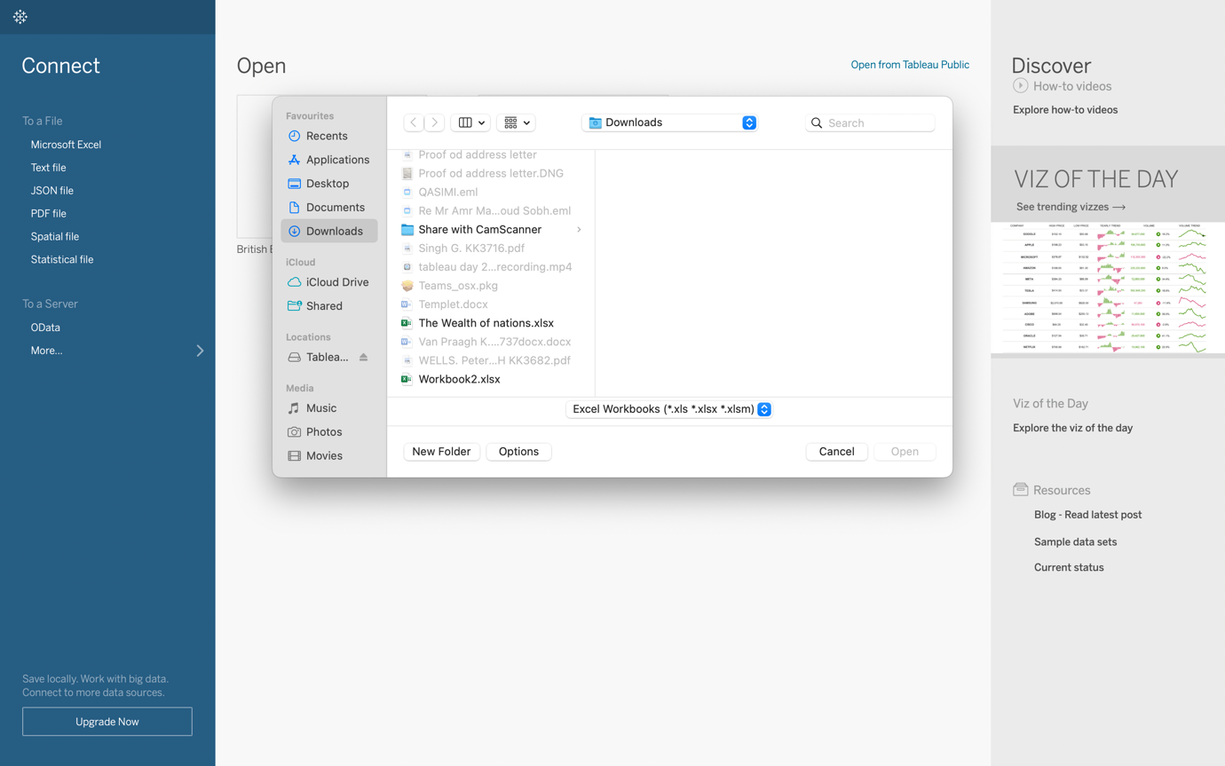

Step 2 Opening file on Tableau

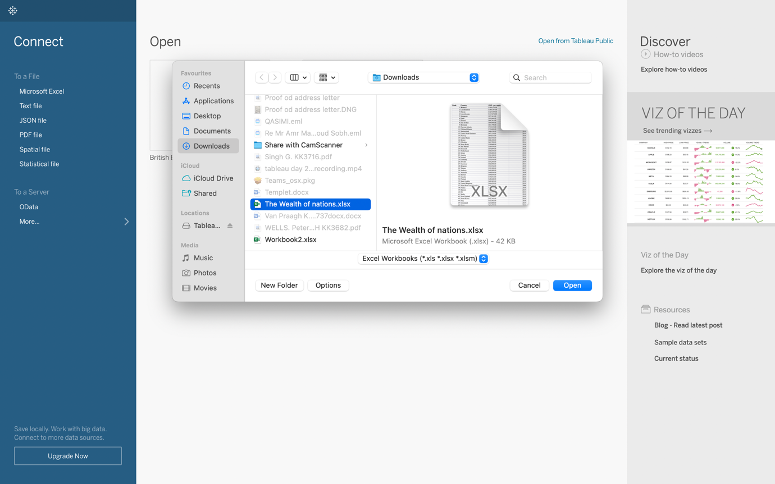

Step 3

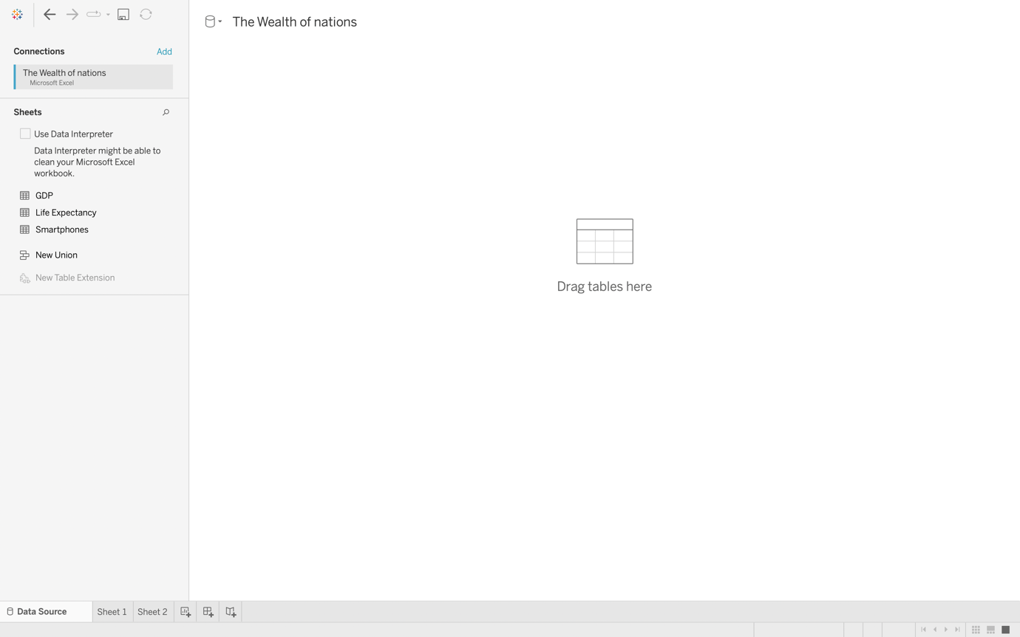

Step 4 Creating connections on Tableau

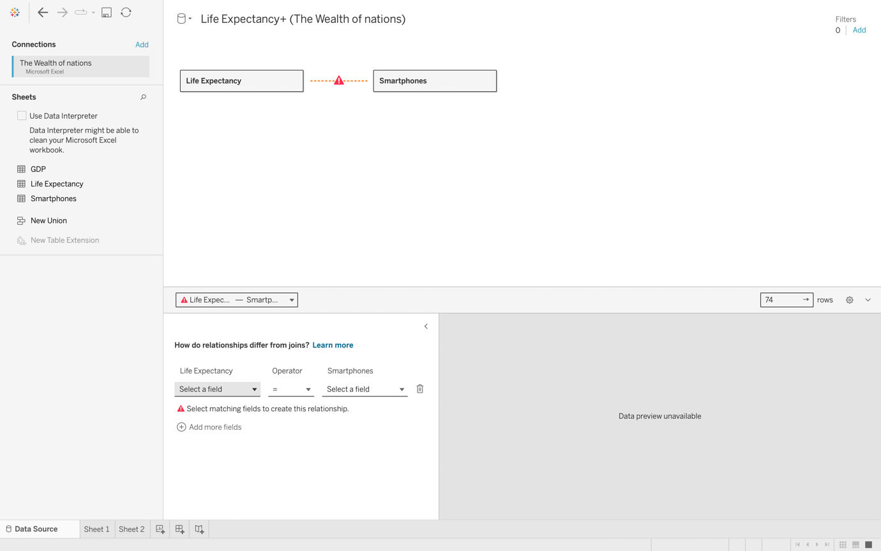

Step 5 Created 2 connections

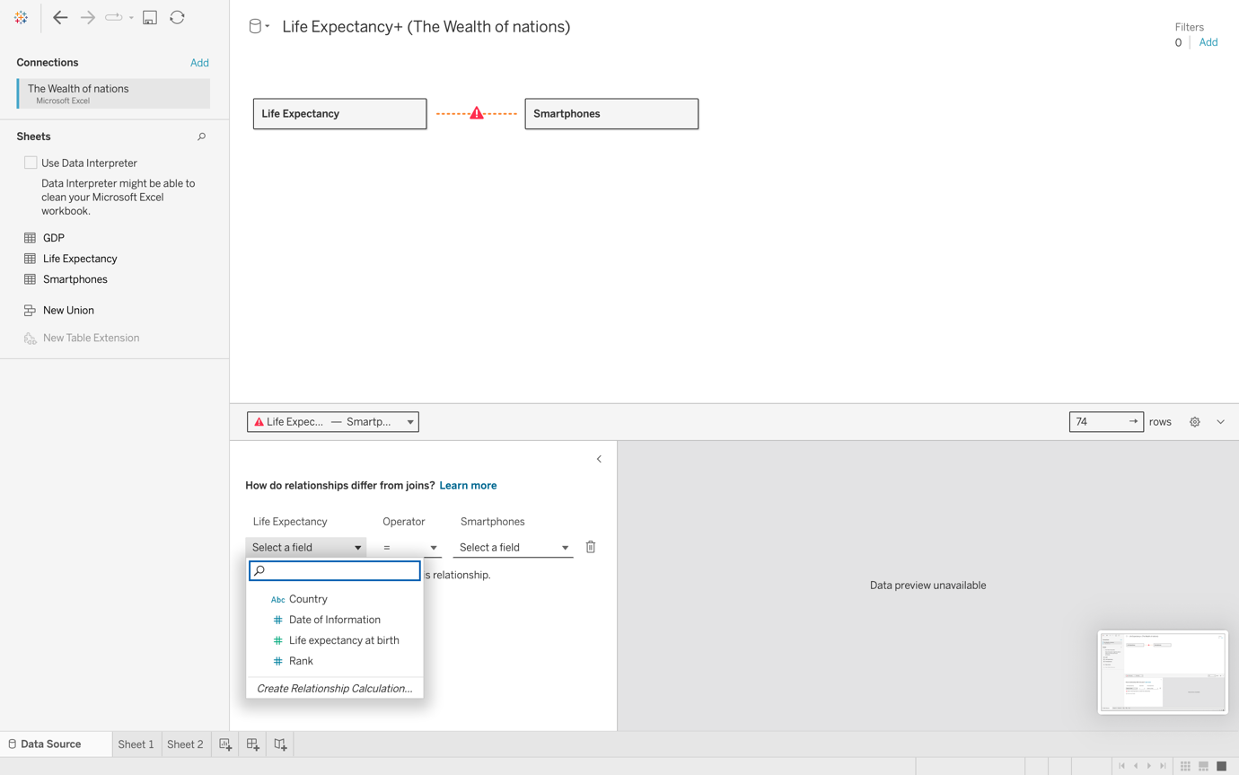

Step 6

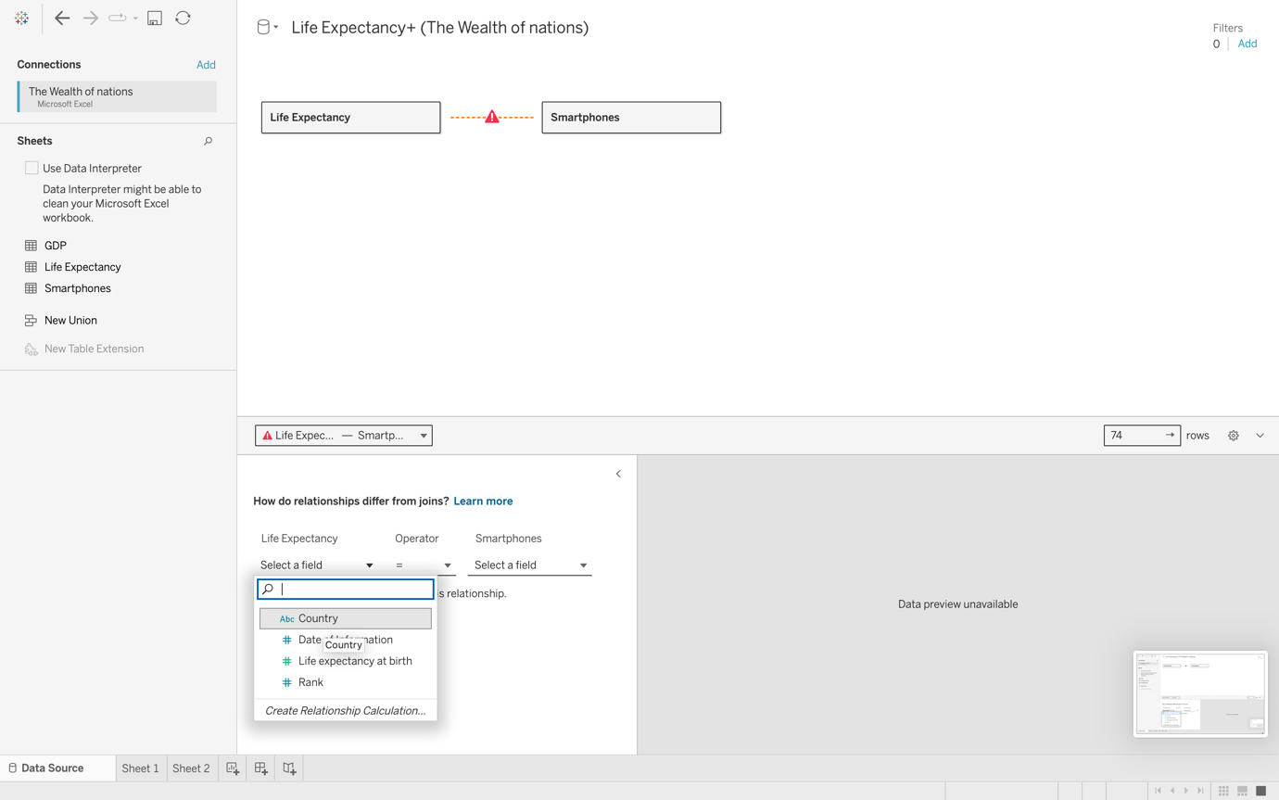

Step 7

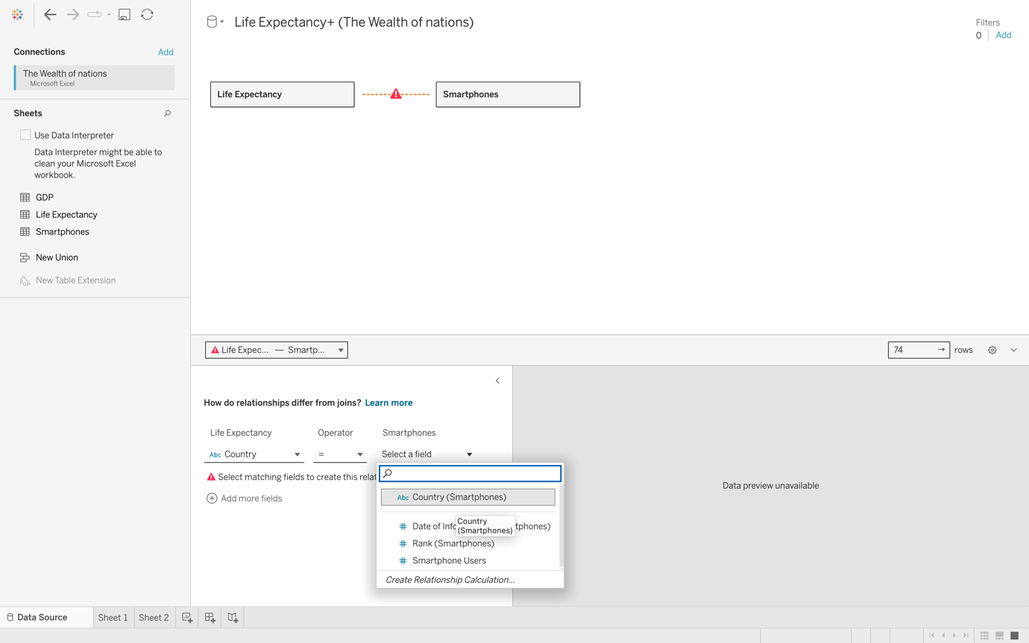

Step 8 Created 3rd connection

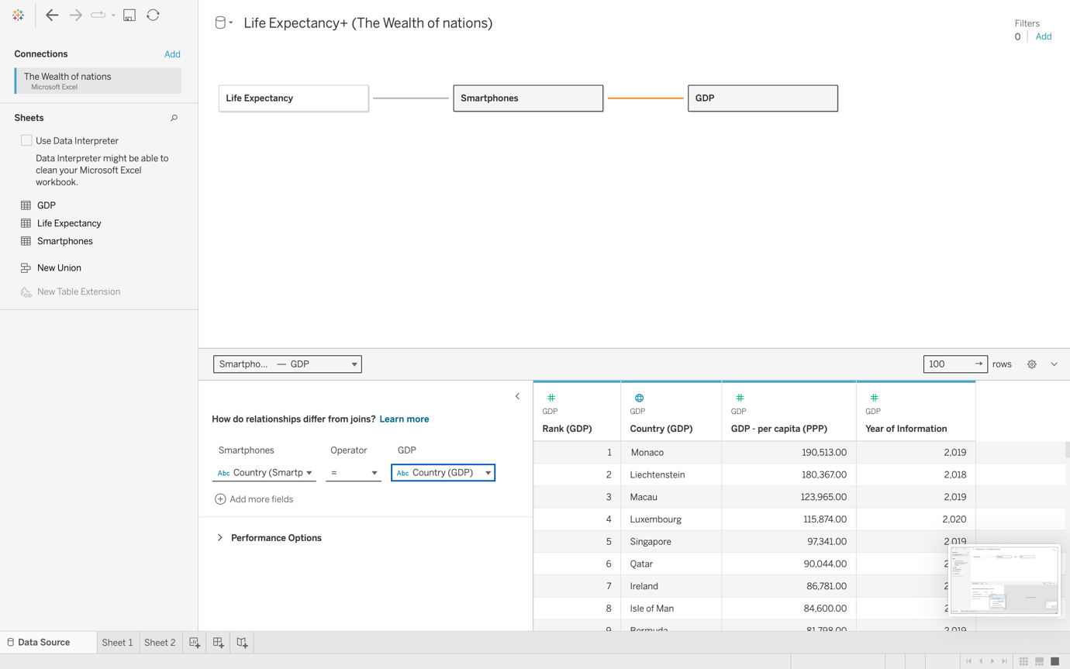

Step 9

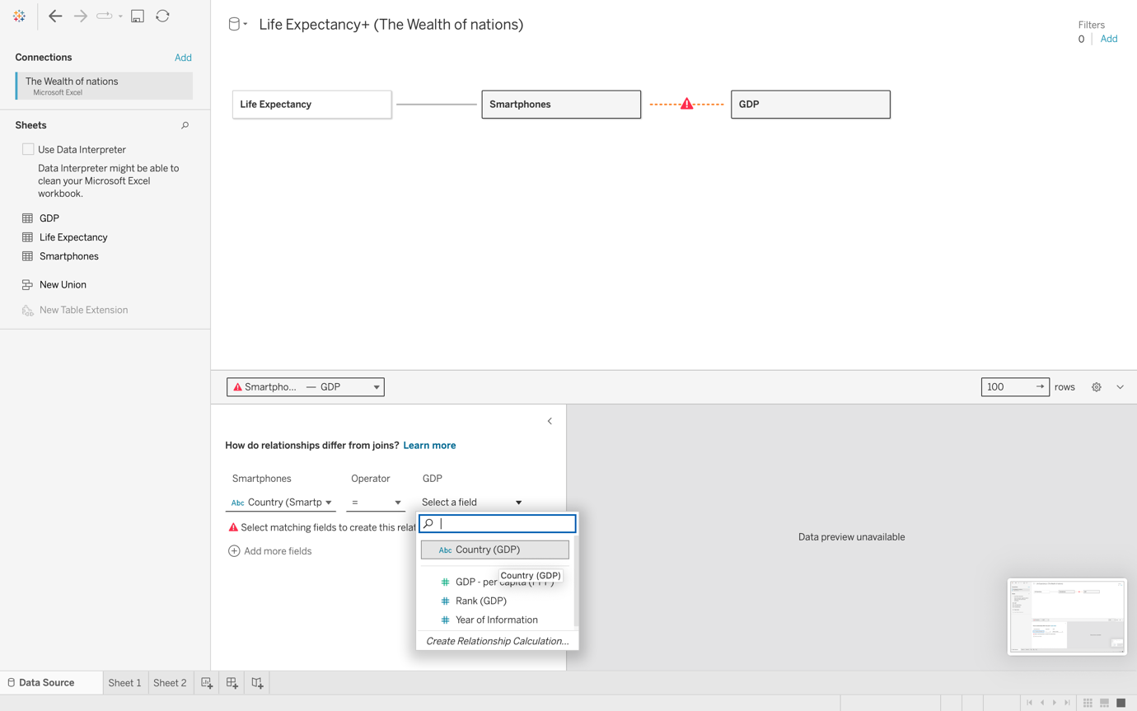

Step 10

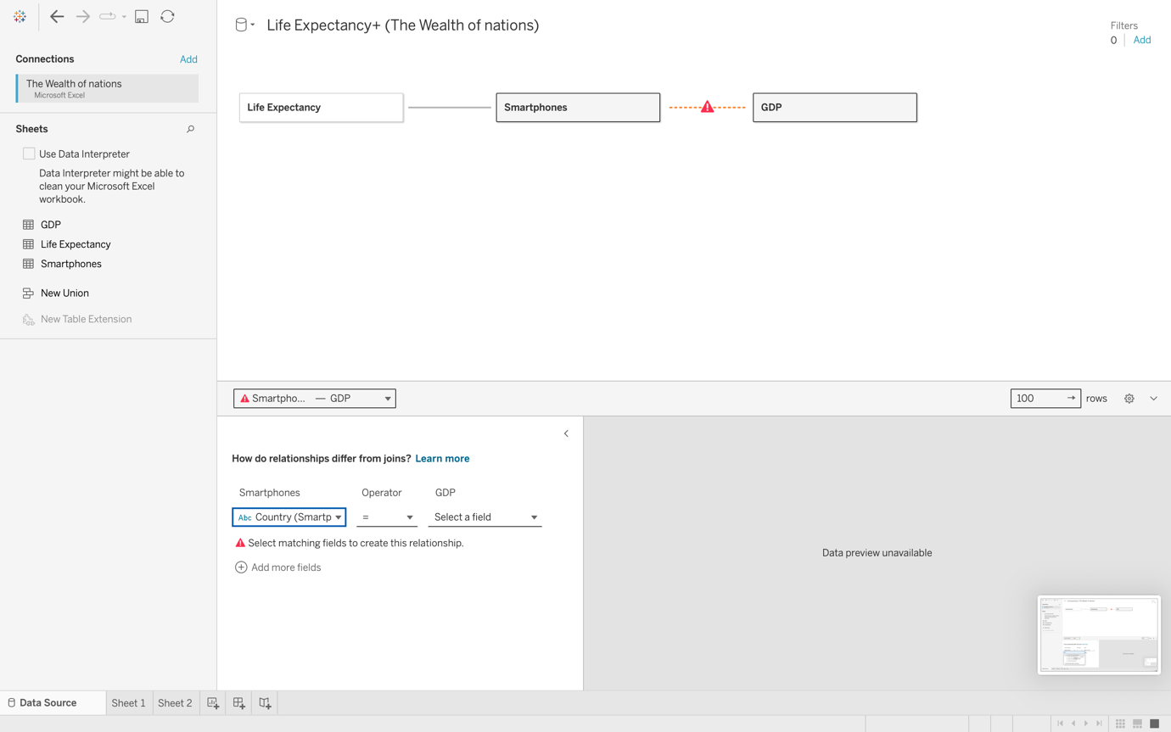

Step 11

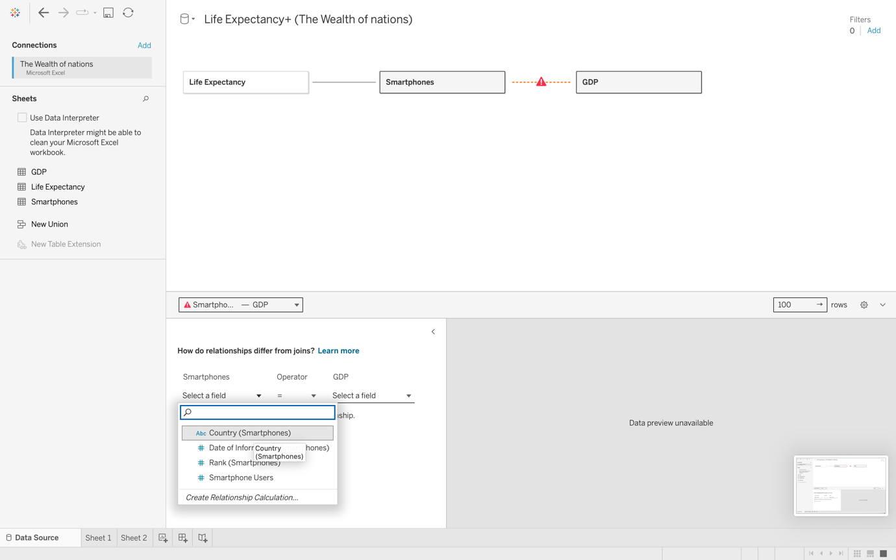

Step 12

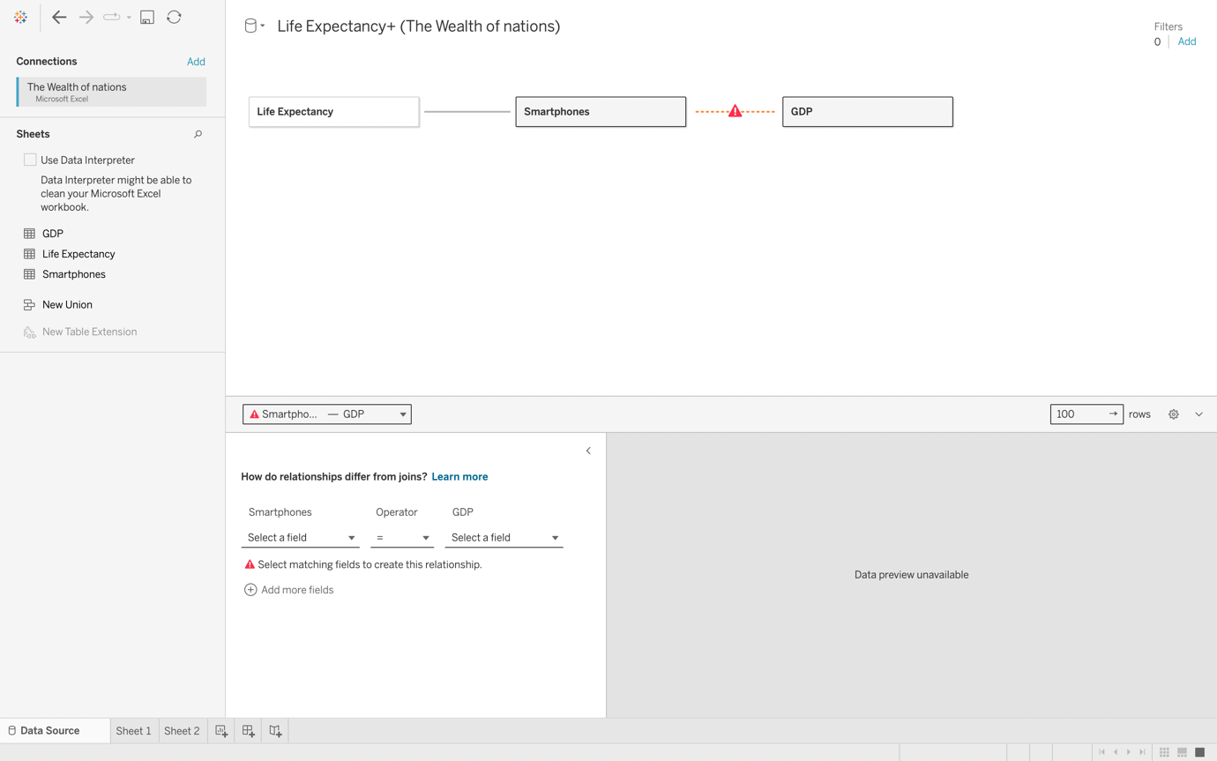

Step 13

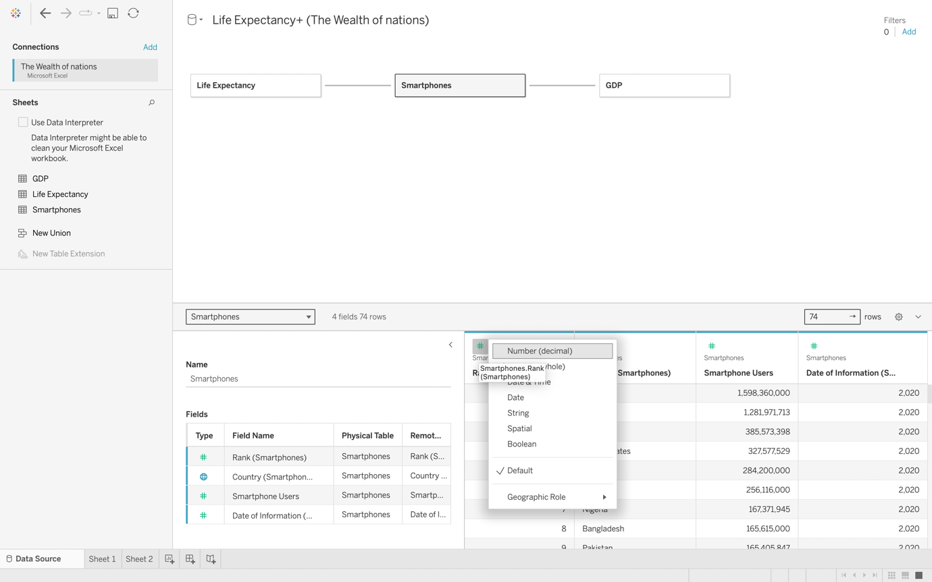

Step 14

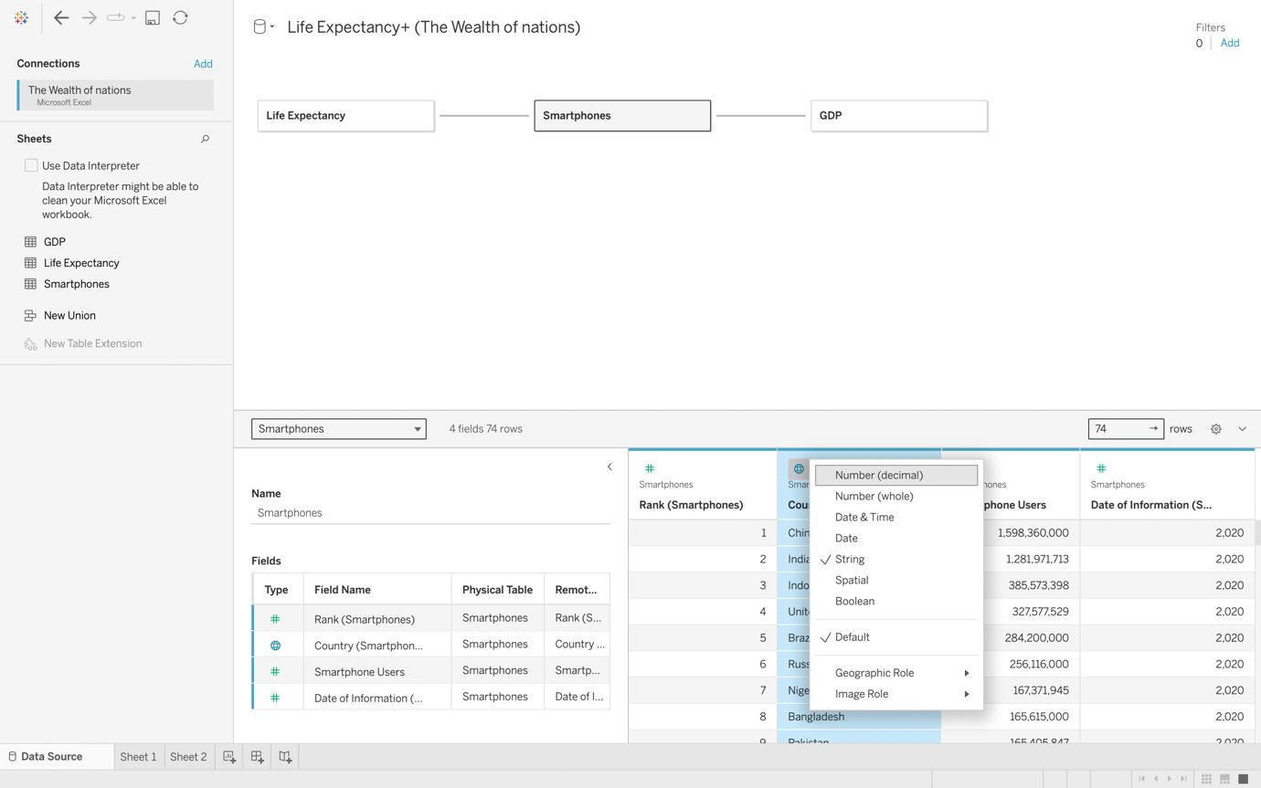

Step 15

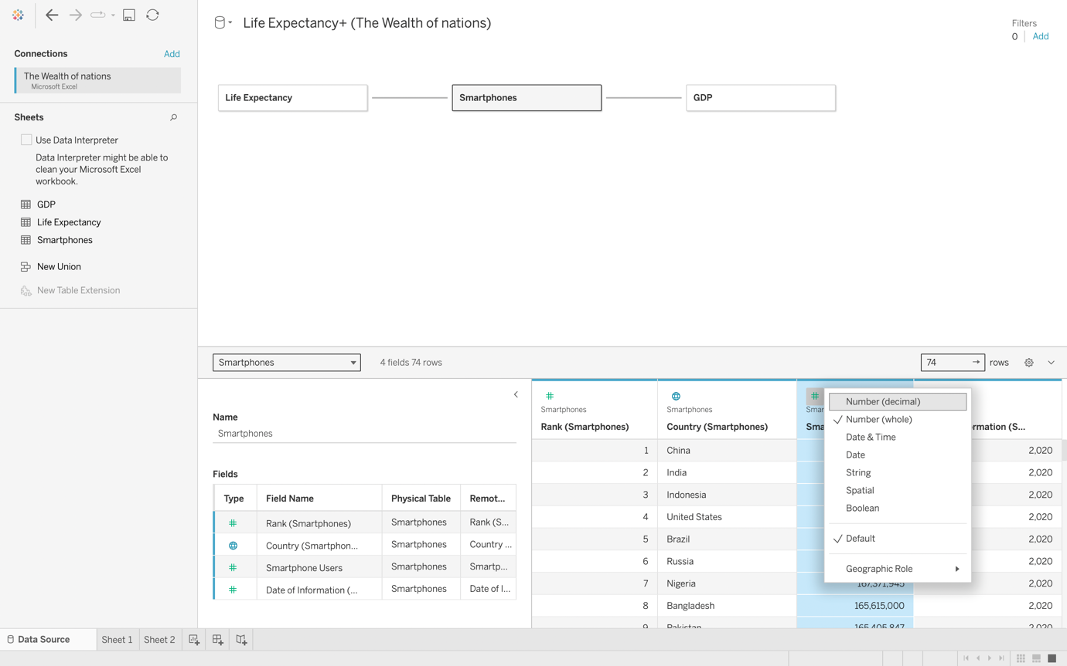

Step 16

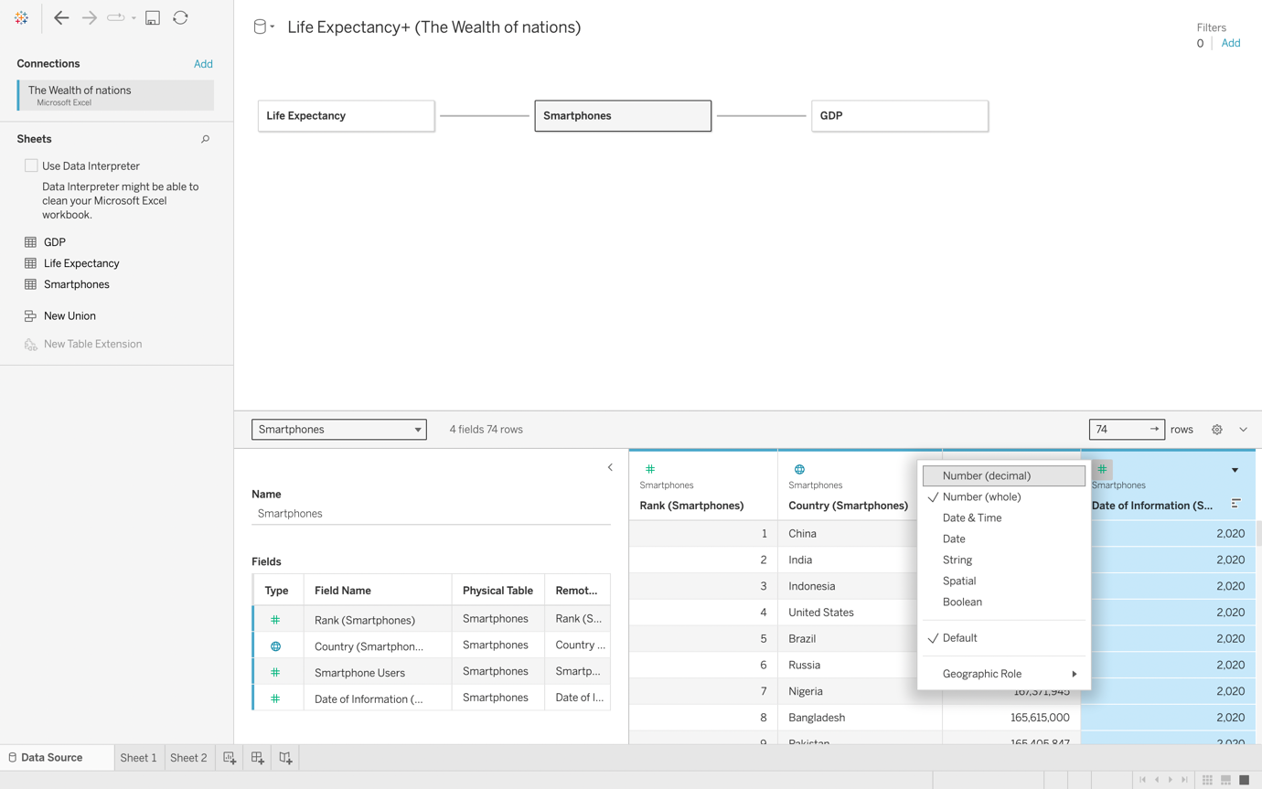

Step 17 Created a chart

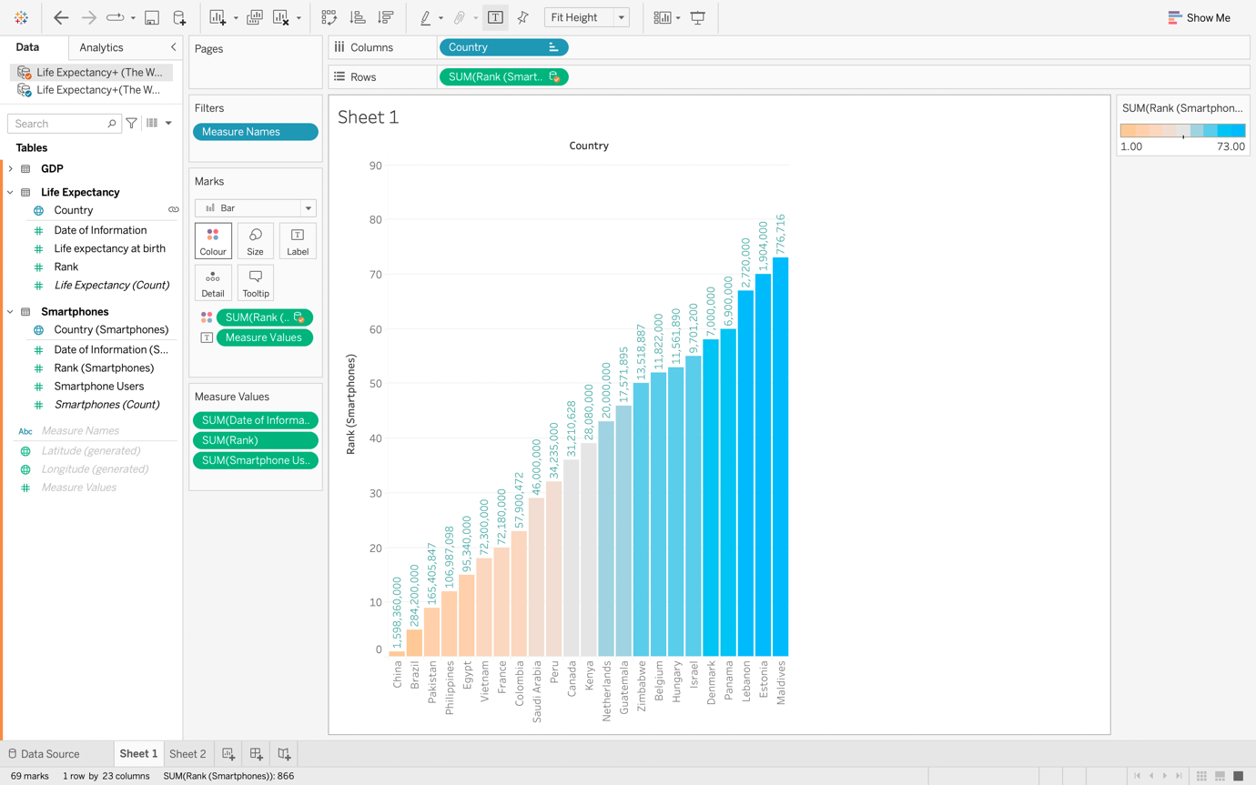

Step 18

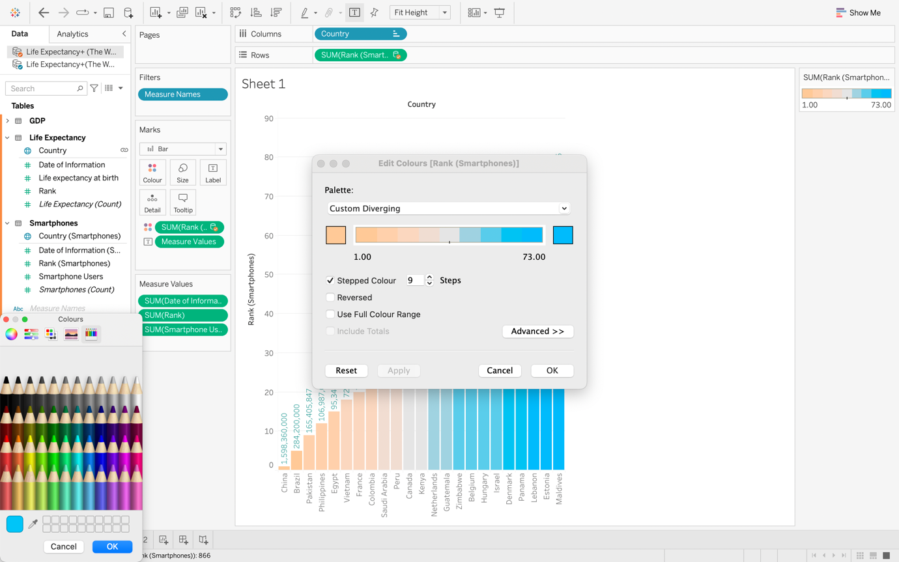

Step 19

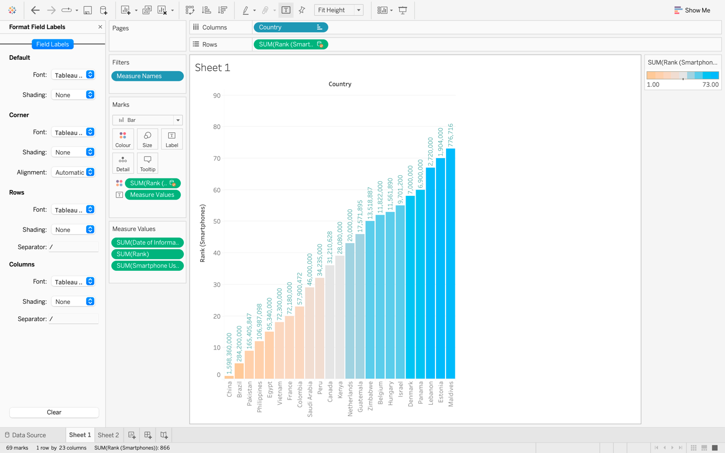

Step 20

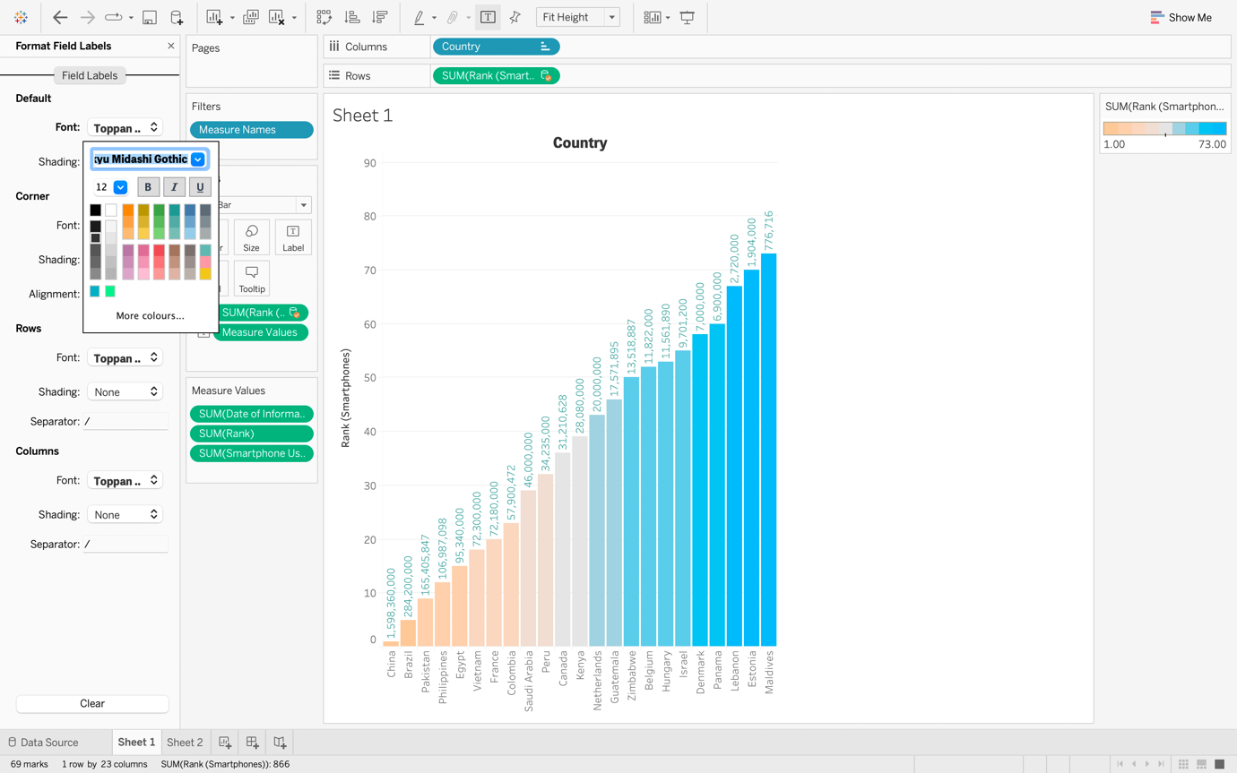

Step 21

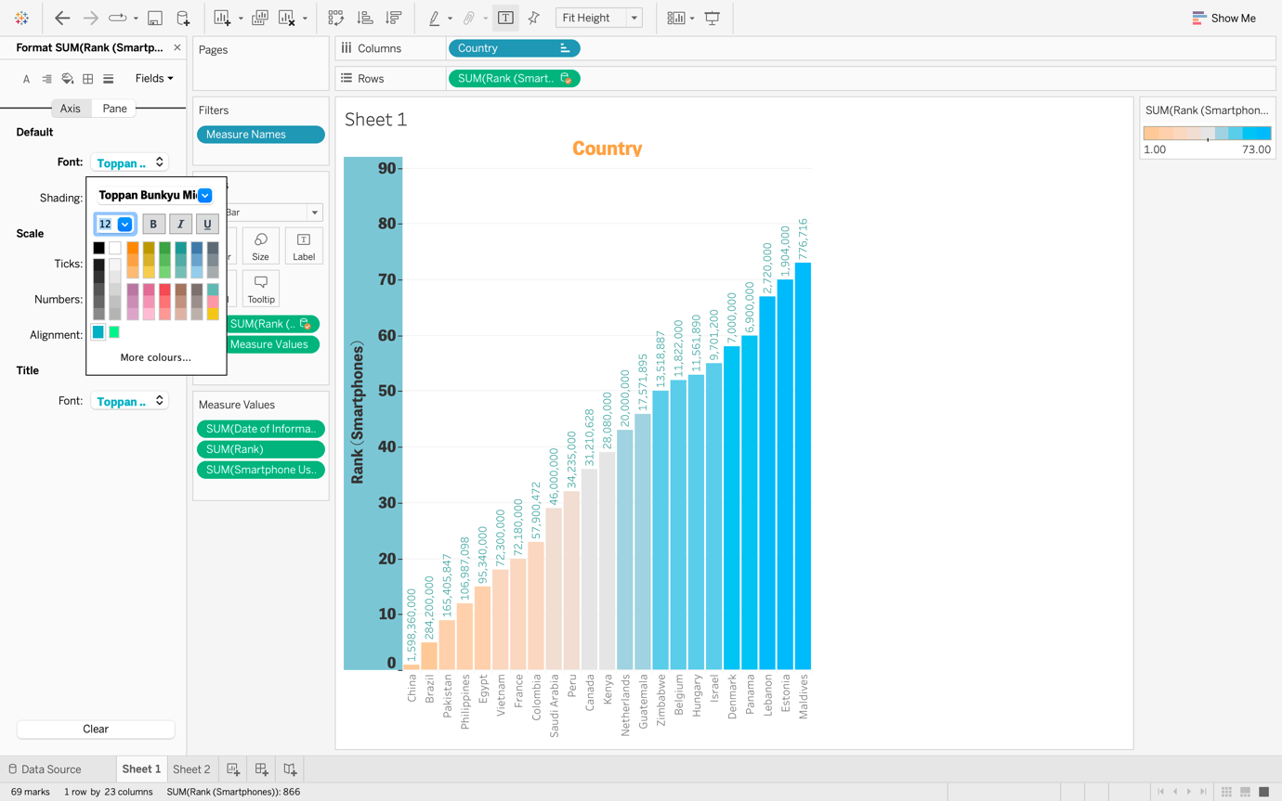

Step 22

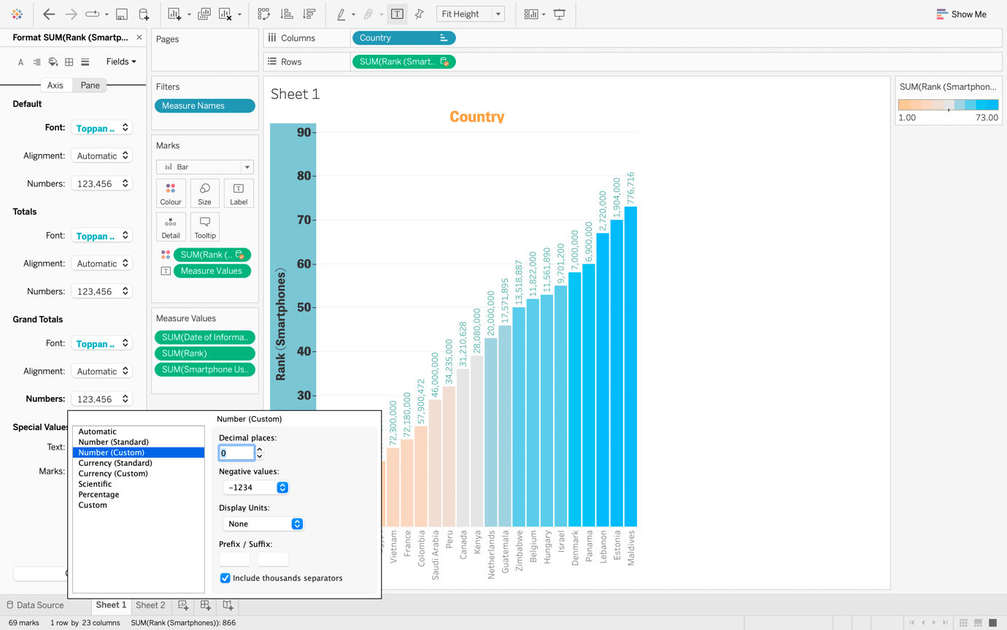

Step 23

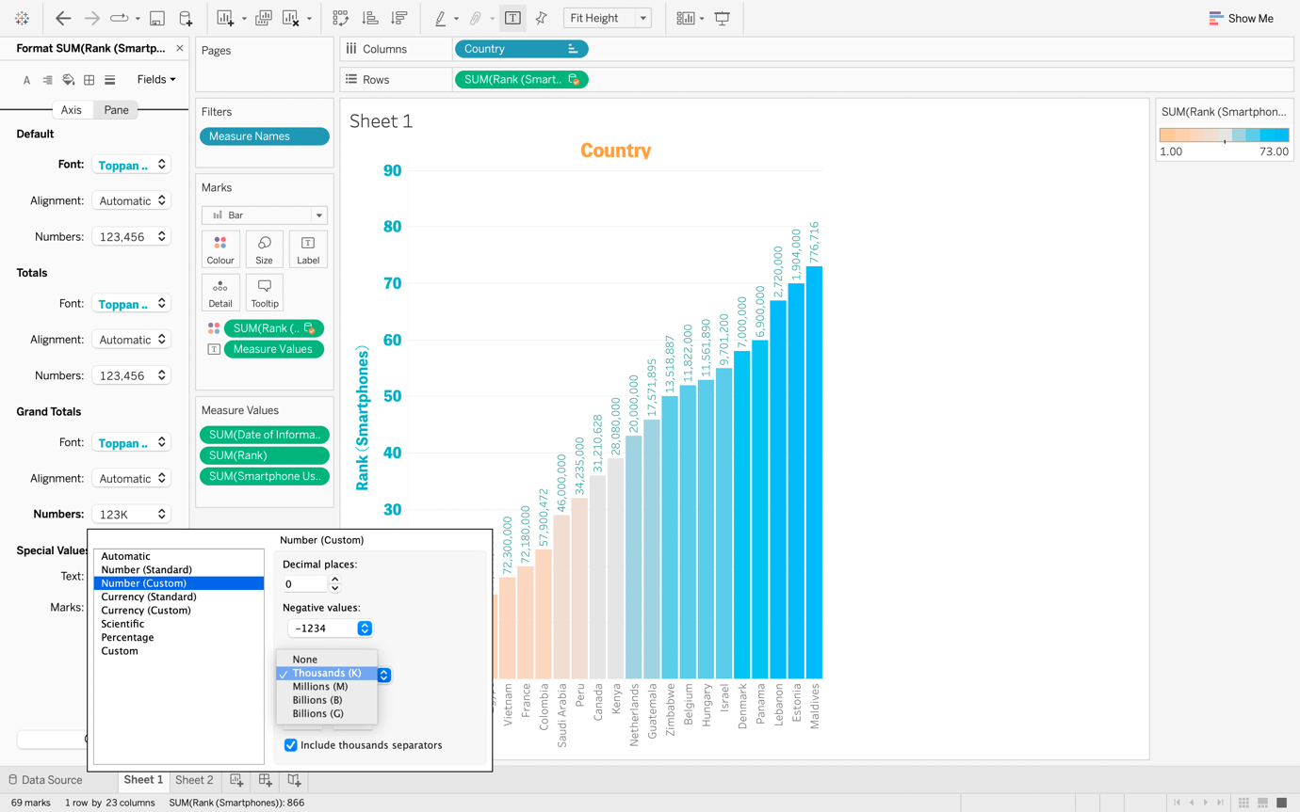

Step 24 Formating

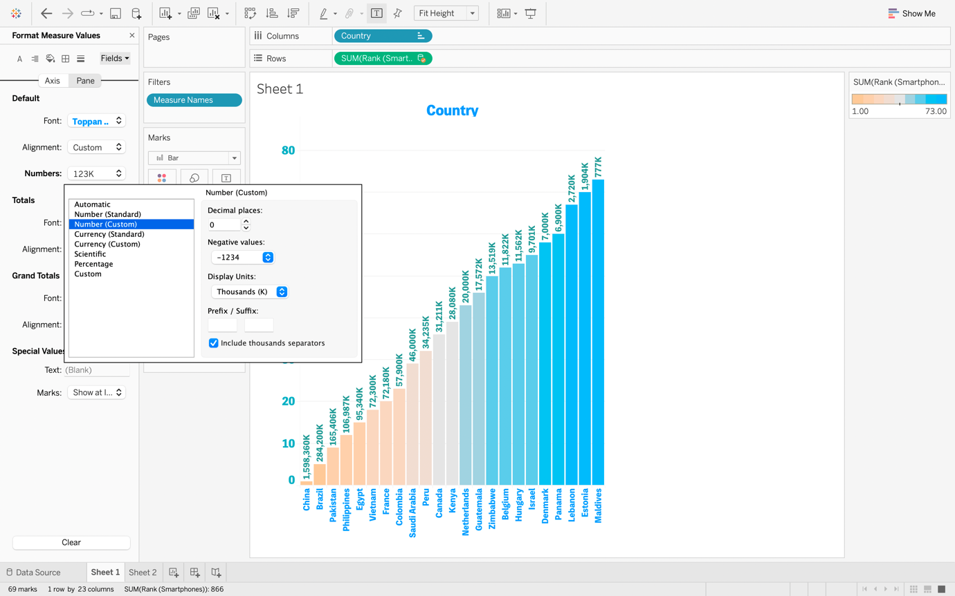

Step 25

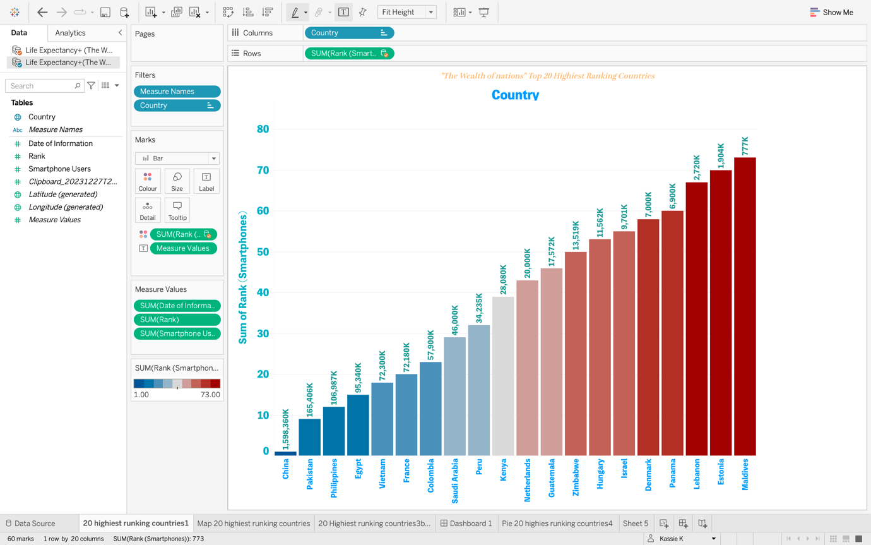

Step 26 Creating a Map chart visualisation

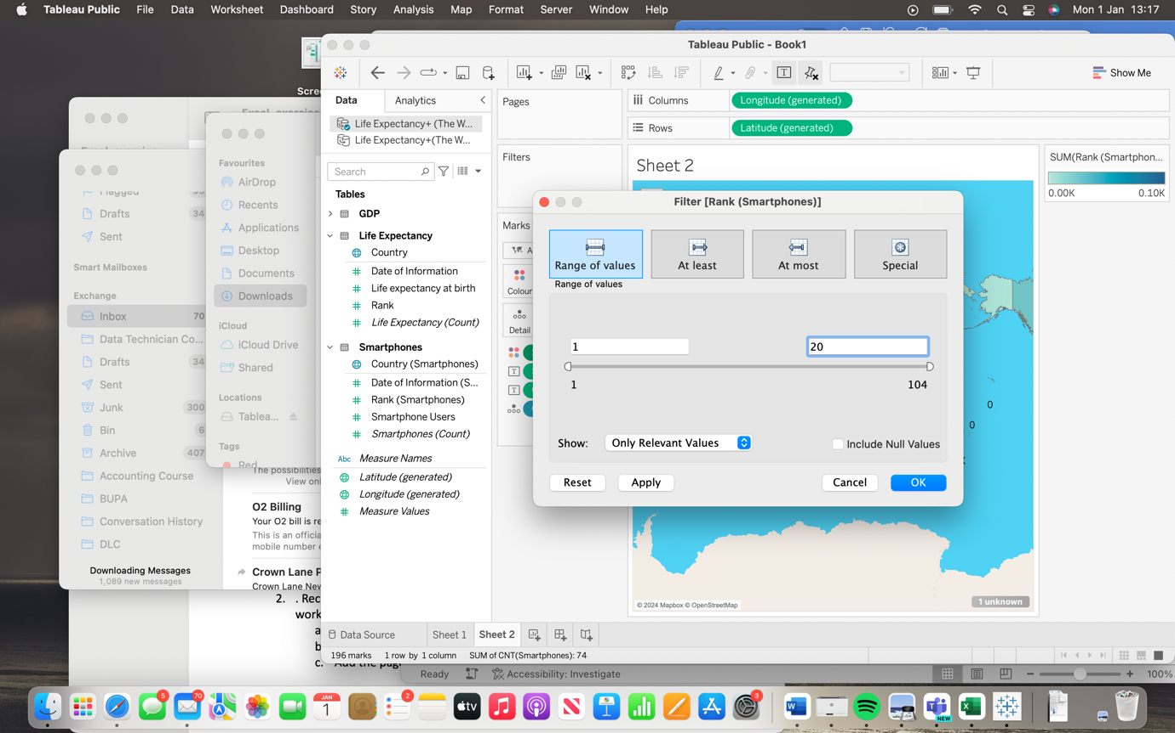

Step 27 Filtering

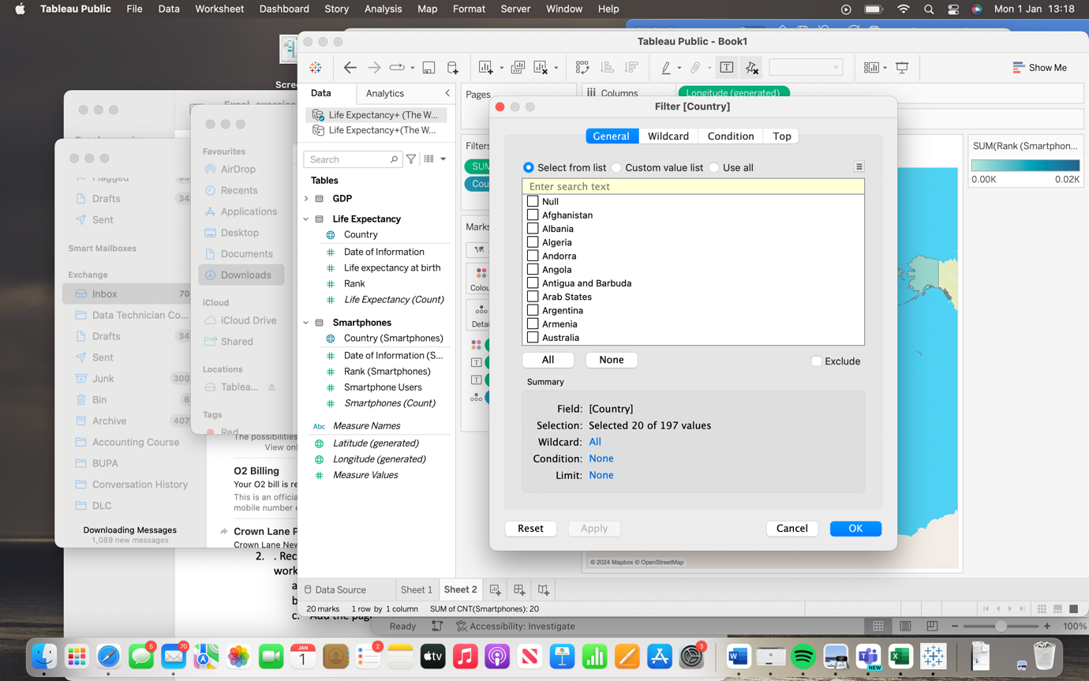

Step 28

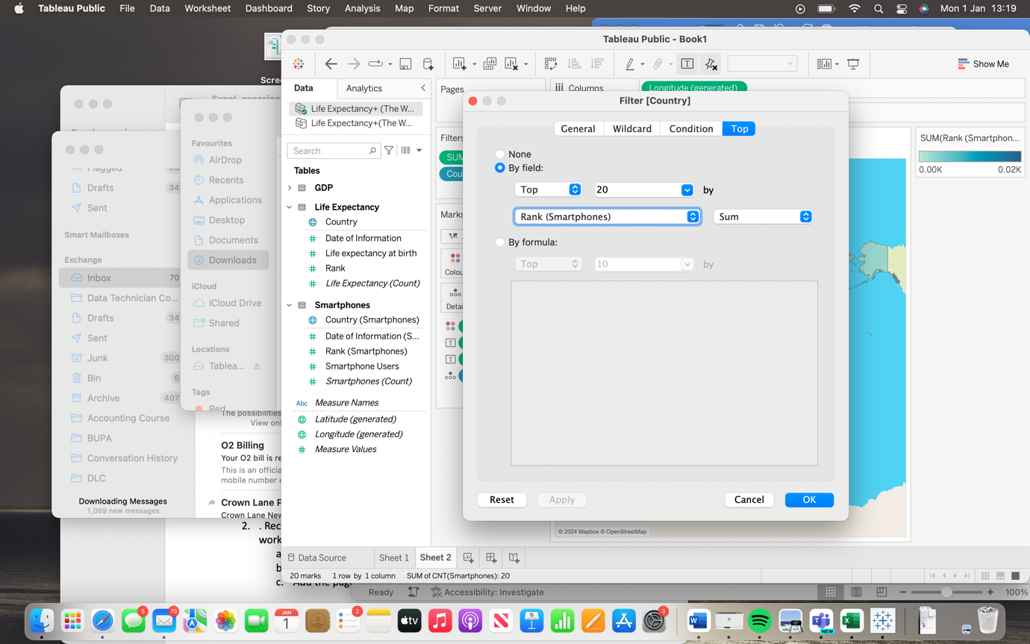

Step 29

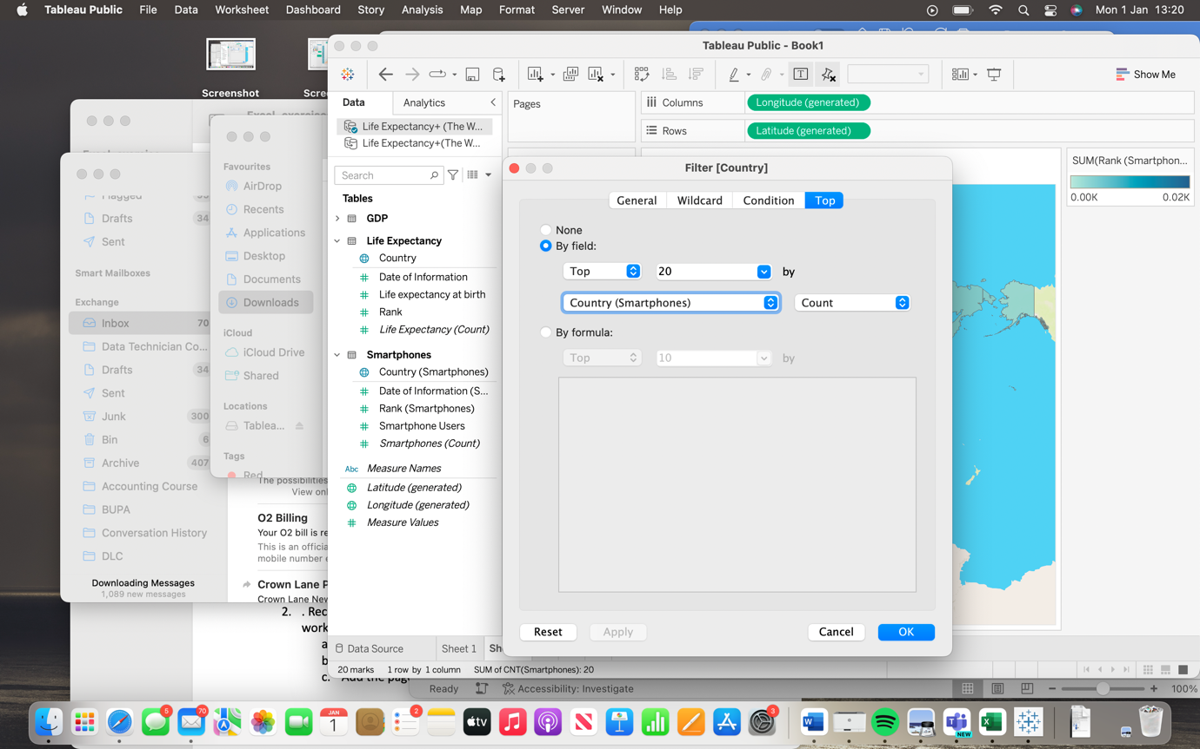

Step 30

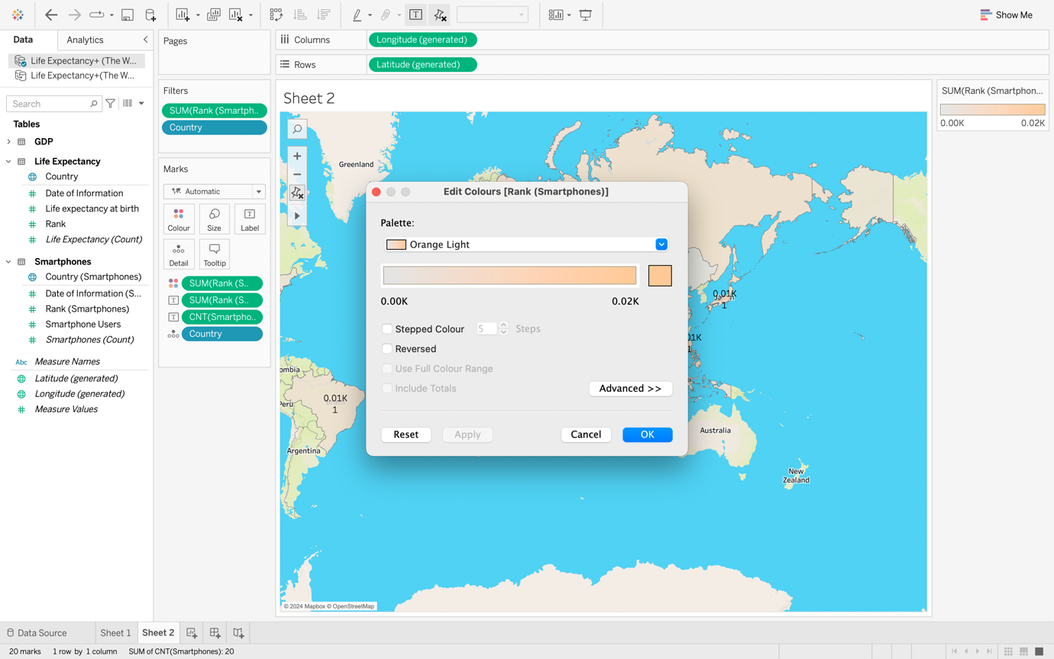

Step 31

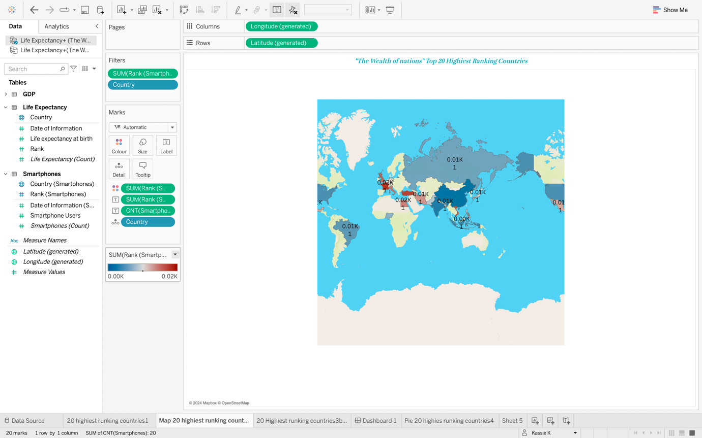

Step 32 Creating a bubbles chart

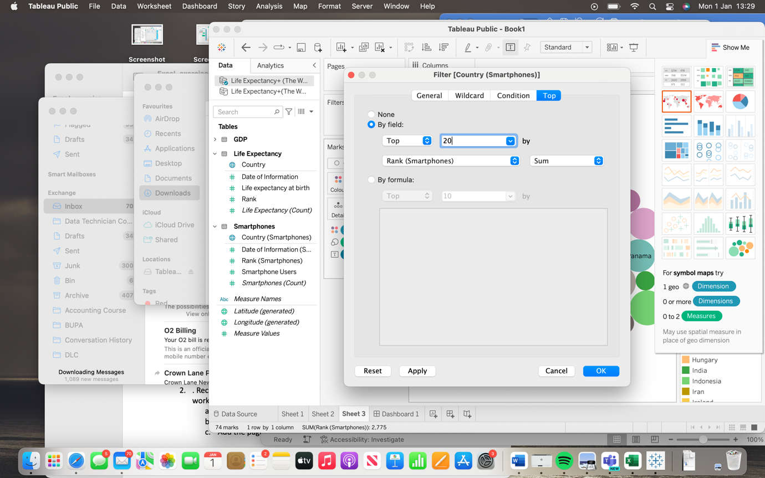

Step 33

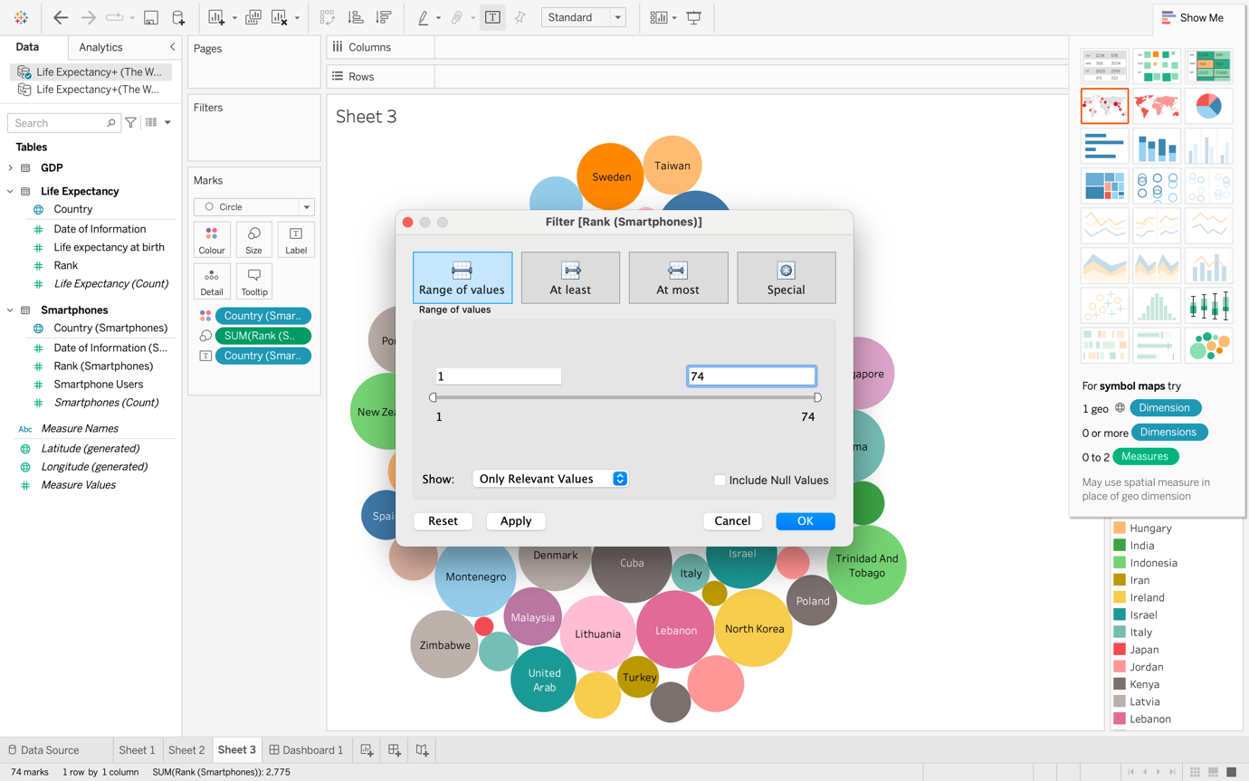

Step 34 Filtering

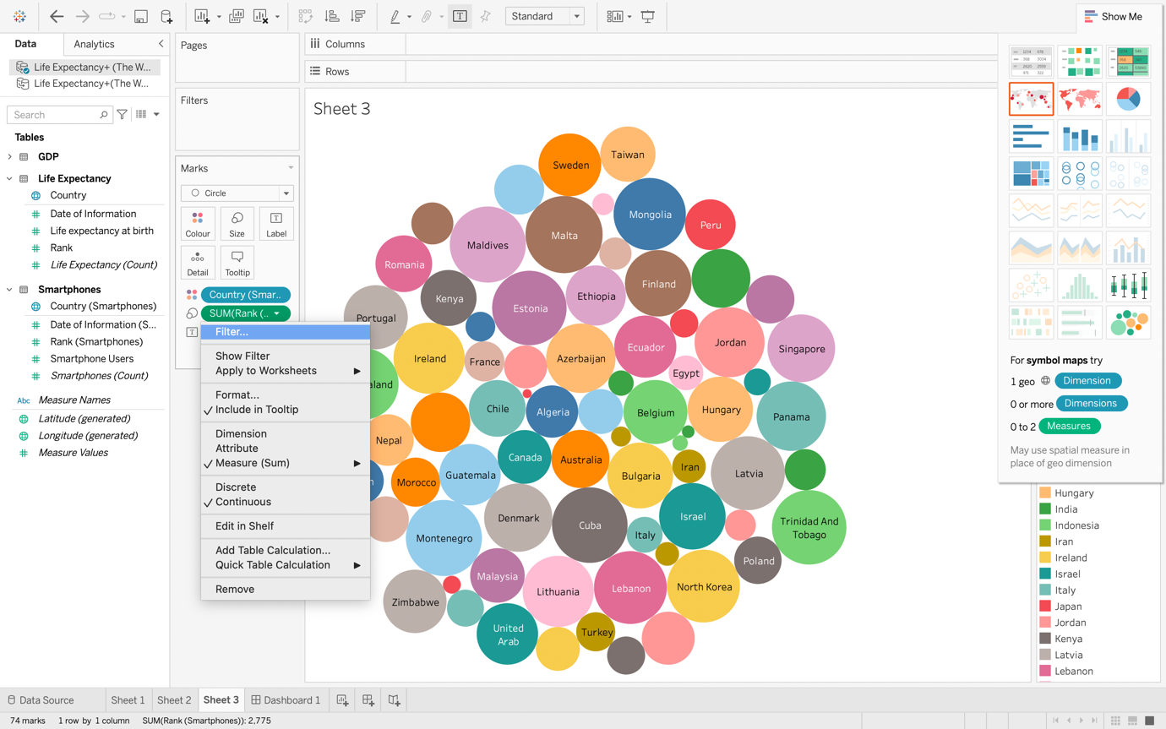

Step 35Filtering

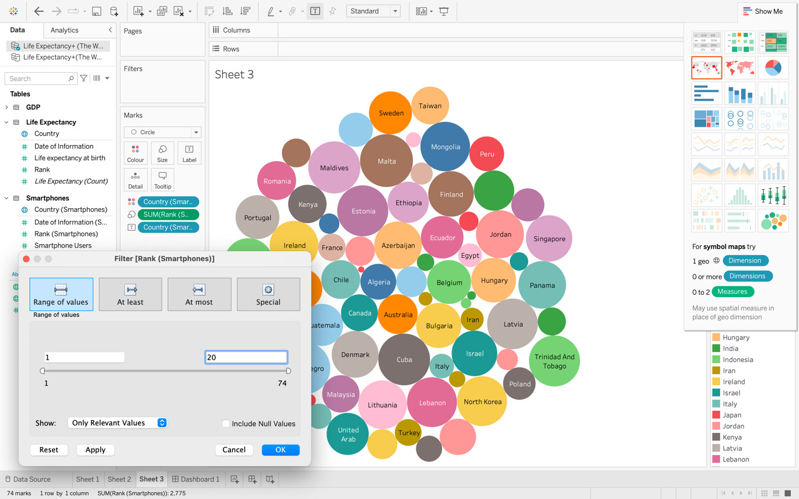

Step 36

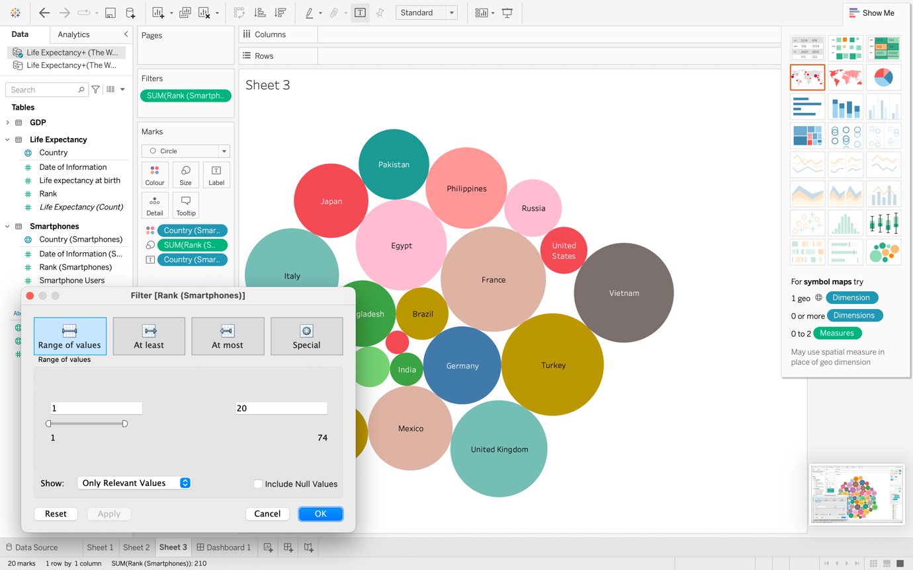

Step 37

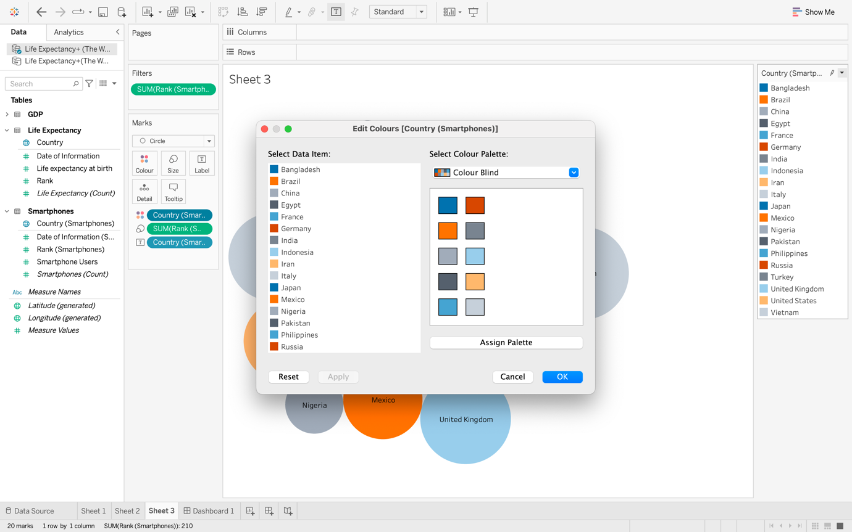

Step 38

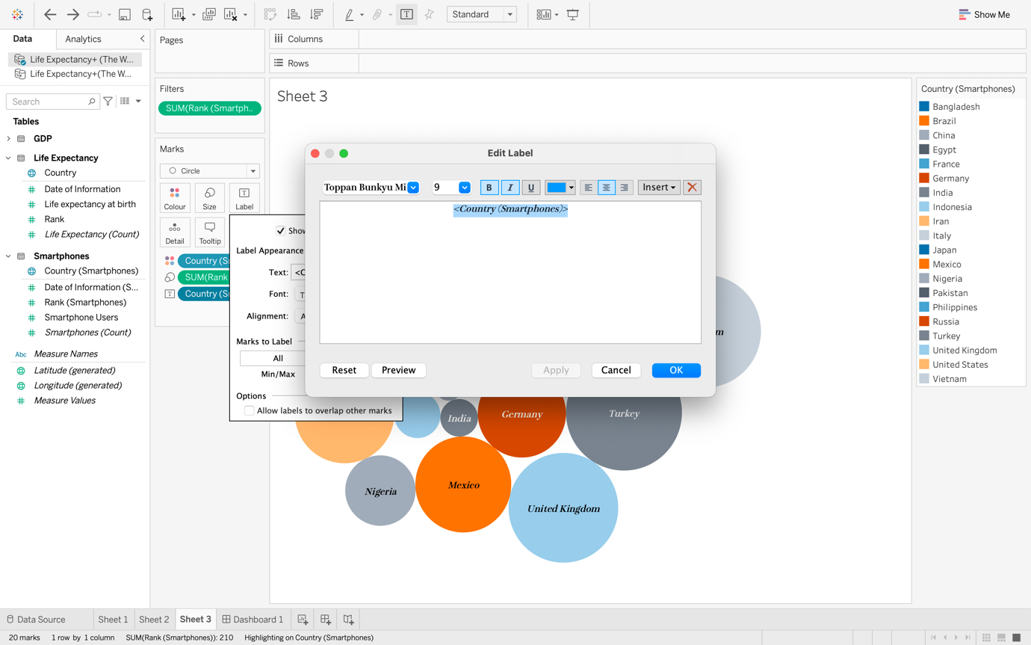

Step 39

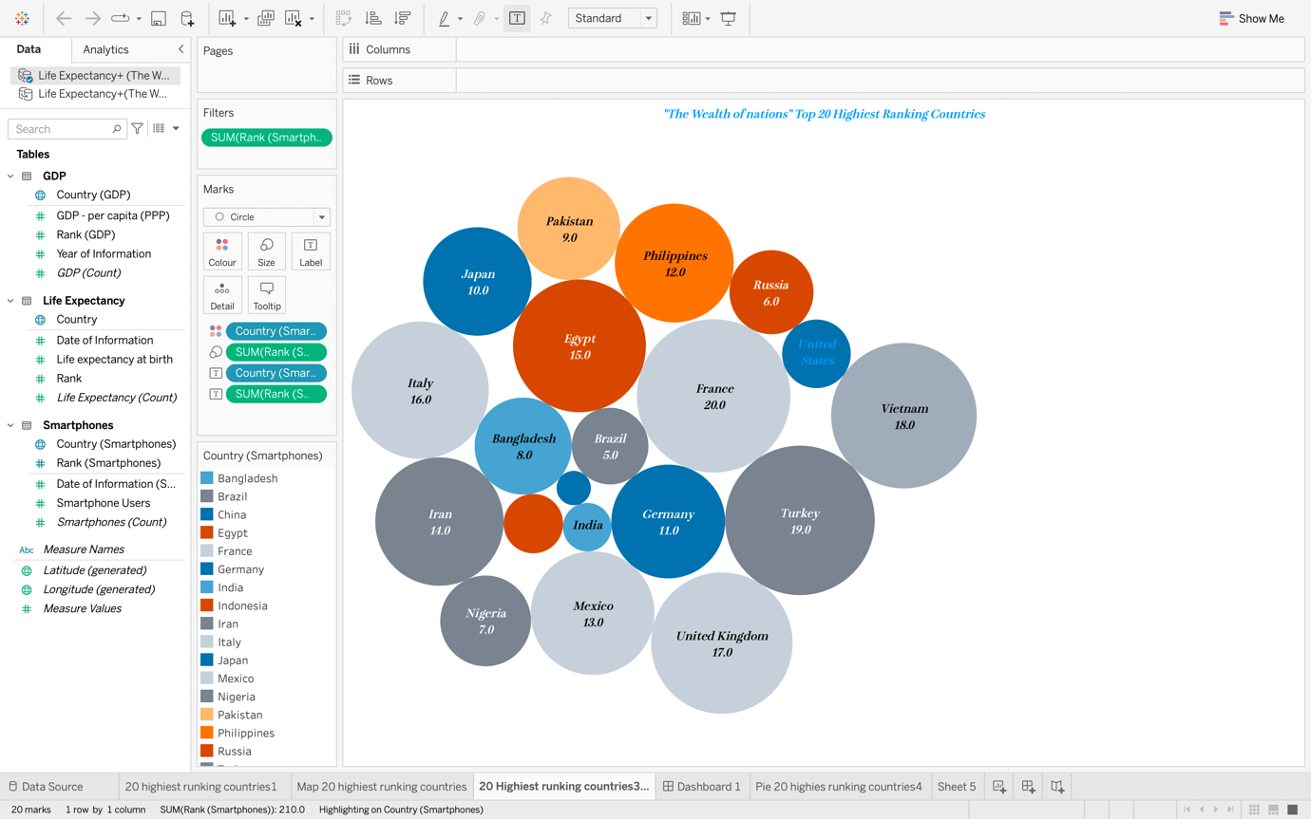

Step 40 Creating a pie chart

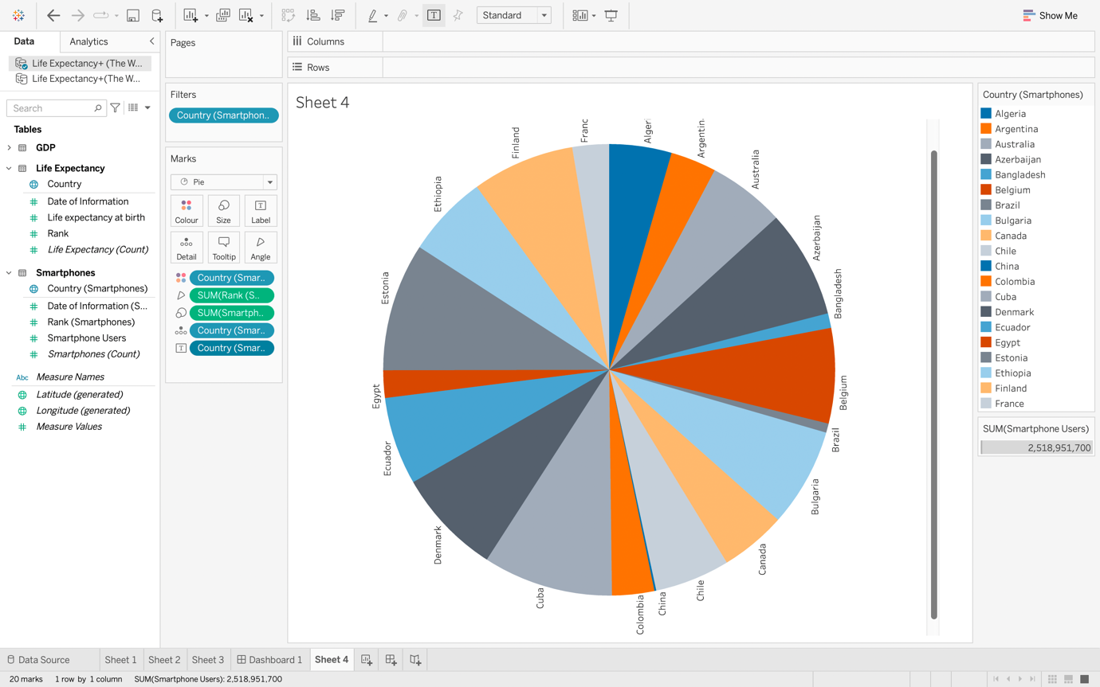

Step 42

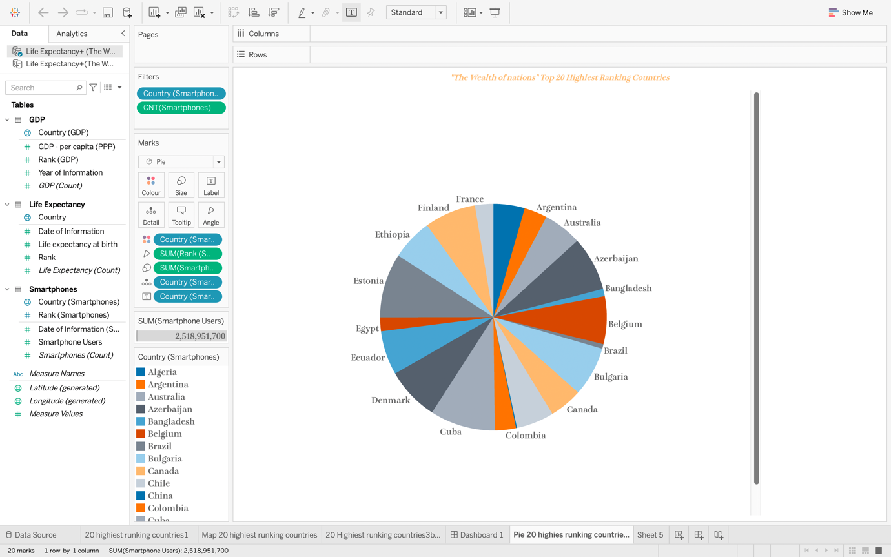

Step 43 Creating a Dashboard on Tableau

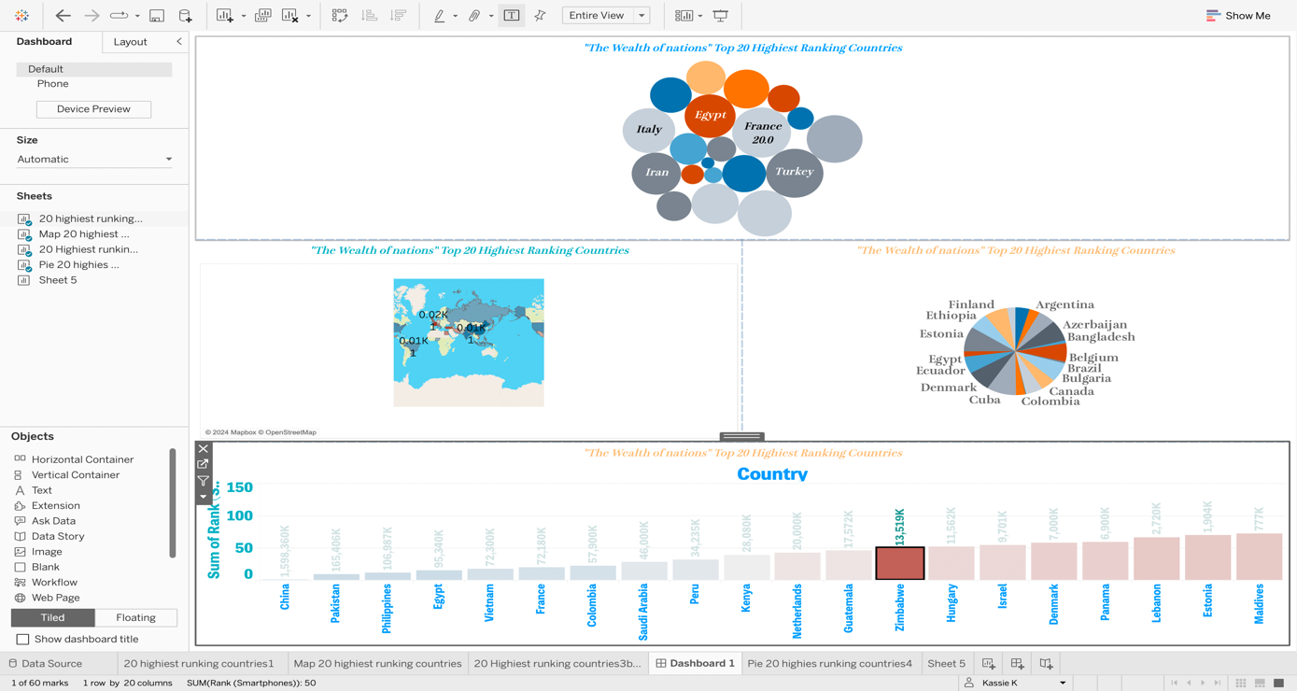

Step 44

Tableau [dashboard](https://public.tableau.com/app/profile/kassie.k6320/viz/TheWealthofNations-assigment/Dashboard1#1).